Preparing a seedbed with Pöttinger
Rigid LION power harrows get a facelift
The power harrow plays an important role in many arable farming scenarios. Best quality tilth and excellent mixing of the soil to form a perfect seedbed are highlights of Pöttinger power harrows. Combined with a seed drill, this machine becomes a flexible and high output combination delivering perfect drilling results. The tailor-made Pöttinger solution features LION power harrows with working widths from 2.5 m to 4.0 m and multiple equipment options to cover all types of soil and different farm sizes.

The best working results
A perfectly prepared seedbed features a uniform, level finish, an ideal proportion of tilth and optimum consolidation. Thanks to the intelligent configuration of the rotors, the machine actively cultivates right to the outside from side board to side board. This creates perfect germination conditions over the full working width for rapid and uniform growth of the plants. The tine carrier is completely integrated into the rotor beam. This ensures excellent reliability because no soil flows above the rotors. Harvest residues cannot become snagged and no separate stone guard is necessary.

Universal tines for every situation
LION power harrows with 3.3 rotors per metre of working width can be used both as harrows and cultivators. With 4 rotors per metre of working width, the machine can be used on its own as a power harrow. All that is needed to change the application is for the tines to be repositioned. The sweeping angle of the tines produces a good tilth structure throughout the working depth. The mulch layer remains near the surface to protect against erosion.
Set to an aggressive angle, the tine breaks up the soil from underneath. This results in good mixing of the soil, with fine tilth concentrated lower down. The same geometry of tine is used for both applications. The tines on LION power harrows have a long service life and ensure consistent, effective tillage of the soil with intensive loosening and uniform crumbling. Optional tungsten coated DURASTAR tines can be selected for an even longer service life.

New: Working width is the same as the transport width
For additional convenience, the side boards do not have to be folded upwards on new models to transport the machine to the next field. The boards are located within the permitted transport width and make full use of the maximum working width. This means it is no longer necessary to modify machines working widths of 3.0 m, 3.5 m and 4.0 m for road transport (the permissible transport width varies from country to country). That saves time.
A sturdy tube section is mounted on the gear trough to protect against stones and against reaching into the work area. This also enables track eradicators to be retrofitted easily.

Clever details
You need to be able to react quickly and easily to different operating conditions. The working depth of the rigid LION power harrows can be flexibly adjusted by simply repositioning the bolts in the 9-hole matrix. Hydraulic depth adjustment is available as an option.
The rear levelling board is standard and is set automatically with the depth of the rear roller. No readjustment is necessary when changing the depth.

Versatile applications
Pöttinger offers a wide choice of heavy power harrows to cover every tractor power range and application in the field. Each gearbox is optimally matched to the respective application and is engineered for a long service life. Three different gearboxes are installed in the respective models.

All models of rigid power harrow, such as the LION CLASSIC series for tractors up to 150 hp, the two series with changeable speed gearboxes - the LION up to 200 hp and the LION MASTER for tractors up to 270 hp are characterised by their smooth and quiet operation in the field and in the headland position.

Photo preview:

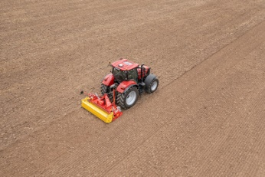 | 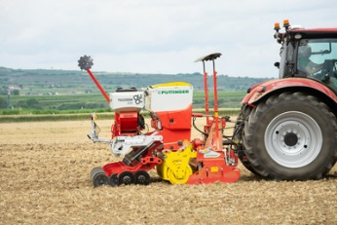
The LION 3030MASTER stands out with its new, eye-catching design | Varying operating conditions are the strengths of the LION 3030 MASTER with VITASEM M 3000 DD
https://www.poettinger.at/de_at/newsroom/pressebild/102541 | https://www.poettinger.at/de_at/newsroom/pressebild/102543

More printer-optimised photos: http://www.poettinger.at/presse

