Pöttinger: short & sharp
Loader wagons and balers deliver short chopped crop for the best forage
When harvesting grass silage, every farm manager wants to obtain the highest possible forage quality to increase profits. Agricultural machinery manufacturer Pöttinger clearly focuses on precisely this requirement when developing its machines. One of the main factors influencing feed quality is the theoretical chopped length. This is exactly where the loader wagons and round balers score with their short chopped length.

On the one hand, short chopped forage leads to a faster pH-value reduction. This reduces the risk of fermentation failure and has a positive effect on the stability of the grass silage. On the other hand, it has a positive effect on livestock health and performance.

Optimum chopped length, which animals appreciate
Cattle only have incisors in the lower jaw, the upper jaw consists of a horn plate. Consequently, the grass is swallowed almost without having been chewed. When it is short chopped, the forage has a larger surface area and more energy is absorbed. In addition, it stimulates salivary flow, which in turn has a positive effect on rumination. The optimum chopped length is between approx. 20 and 60 mm. The higher the proportion of short particles in the segment up to 60 mm, the better the performance of the ruminant.

Pöttinger offers a chopped length of 36 mm on IMPRESS round balers with 32 knives, i.e. loader wagon quality. For the TORRO and JUMBO high capacity loader wagons, the theoretical chopped length is 34 mm.

According to a study by the renowned Austrian research institute JR Josephinum Research Wieselburg, the distribution frequency of particle lengths with TORRO and JUMBO loader wagons is 86 percent with < 40 mm and for particle lengths of 40 – 80 mm is just 11 percent.

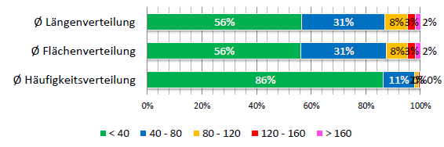
Avg. frequency distribution
Avg. area distribution
Avg. length distribution
Frequency distribution in length classes based on the JUMBO with a theoretical chopped length of 34 mm (Source: Christian Rechberger, JR Josephinum Research Wieselburg, AT)

Perfect cut
Only really sharp knives can guarantee optimum chopping quality, lower power consumption and increased output. The sharpness of the knives deteriorates continuously during intensive operation. When wear increases, the TWINBLADE reversible blades can be turned without the need for tools. This ensures that the knives remain permanently sharp during a long working day or with a high proportion of whole crop.
The IMPRESS round baler also features 32 TWIN BLADE reversible knives in the new pull-out FLEXCUT 32 short chop knife bank. Pöttinger, the world leader in loader wagons, has thus managed to integrate loader wagon chop quality into a round baler for the first time.

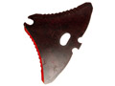
TWINBLADE knives | IMPRESS delivers perfect short chop
https://www.poettinger.at/de_at/Newsroom/Pressebild/3686 | https://www.poettinger.at/de_at/Newsroom/Pressebild/4167

Fully automatic - always sharp
AUTOCUT fully automatic sharpening on the loader wagon guarantees the knives are always sharp during operation. The power requirement and therefore the fuel consumption are up to 20 percent lower as a result. Time spent on maintenance is greatly reduced (by about 45 minutes per day), because automatic sharpening can take place during a break and the driver does not need to clean and grind the knives after a long working day.
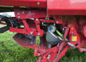
Cutting edge advantages with AUTOCUT
https://www.poettinger.at/de_at/Newsroom/Pressebild/1881

The loader wagon and round baler processes guarantee the best quality forage and silage at low harvesting costs and high output thanks to the optimum chop length.
Satisfied farm managers from various countries confirm that "The chopped length is ideal for livestock health. In addition to saving costs compared to the self-propelled harvester, this system guarantees the best silage."

Photo preview:

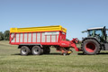 | 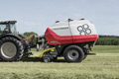
TORRO 7010 L COMBILINE | IMPRESS 155 V PRO
https://www.poettinger.at/de_at/Newsroom/Pressebild/3934 | https://www.poettinger.at/de_at/Newsroom/Pressebild/3812

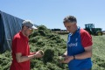
Graham and Stephen Radford (UK) are impressed with the chopped length delivered by the Pöttinger loader wagon
https://www.poettinger.at/de_at/Newsroom/Pressebild/4165

