TERRADISC: High strength thanks to TWIN ARM

Incorporating cover crops in spring, stubble cultivation in summer and seedbed preparation in autumn, the Pöttinger TERRADISC compact disc harrow is suitable for a wide range of applications throughout the arable season. The TERRADISC compact disc harrow is available with working widths between 3 and 10 metres.
The results produced by a disc harrow depend on the stability of the disc mounting. The soil is moved effectively only if each disc cultivates without any deviation.
The central element in this respect is the TWIN ARM system. This features mountings that have two disc carriers each. The wide clamping bracket reliably guides the 580 mm diameter discs through the soil. It also prevents lateral movement, even in heavy soil and dry conditions.
The disc carriers are implemented in high strength cast iron, are extremely resistant to stress and have a long service life. Rubber elements serve as overload protection and allow an upward movement.
High volumes of organic matter can easily be handled by Pöttinger TERRADISC compact disc harrows thanks to their high frame clearance. The aggressive angle of the discs enables homogeneous mixing of soil and plant residues.
The working depth of 5 to 15 cm is regulated using swing clips, which are easily accessible from the front of the machine.
The working widths between 3.0 and 10.0 metres listed for the TERRADISC models correspond to the effective working width. This means you get maximum efficiency with the highest output.

Photo preview:
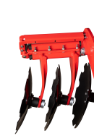 | 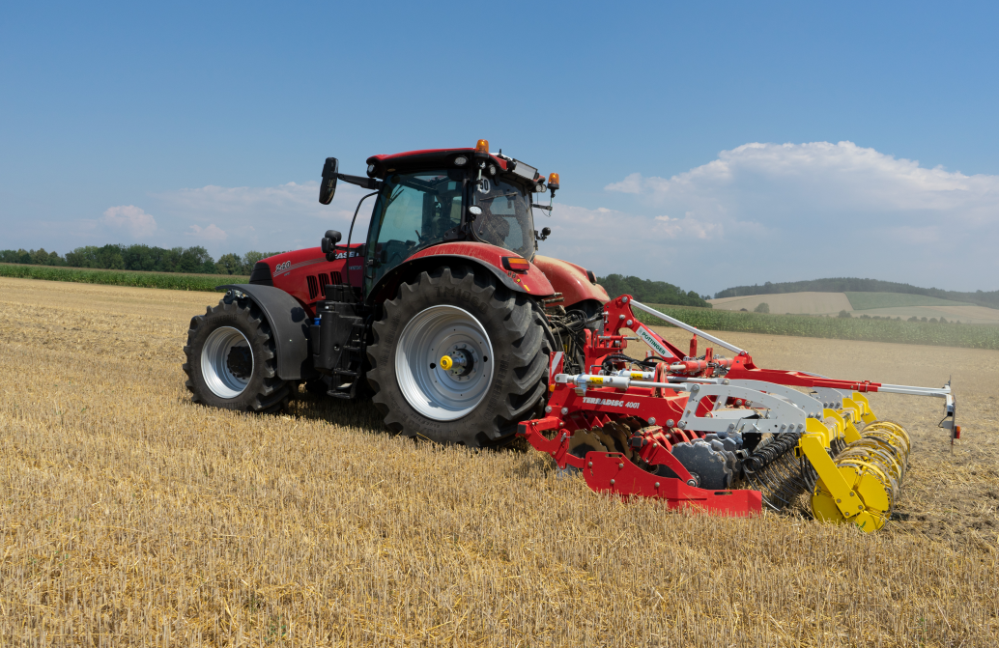 | 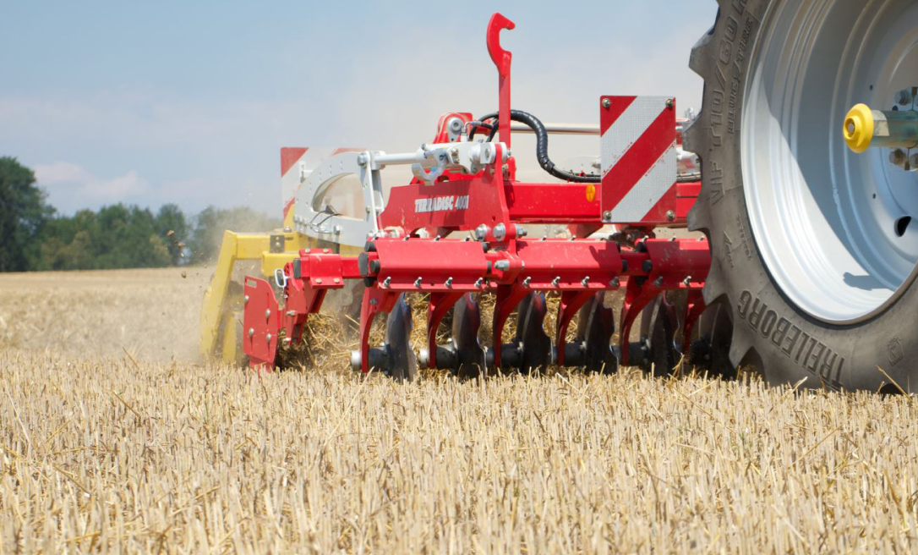
TWIN ARM new | TERRADISC 4001 K | TERRADISC 4001 K  with TWIN ARM
https://www.poettinger.at/de_at/Newsroom/Pressebild/4472 | https://www.poettinger.at/de_at/Newsroom/Pressebild/4473 | https://www.poettinger.at/de_at/Newsroom/Pressebild/4474

More printer-optimised photos: http://www.poettinger.at/presse

