One for all from Pöttinger:
TEGOSEM, the tank for flexible application
The TEGOSEM hopper made by Pöttinger is available as an option for a wide range of machines. With the TEGOSEM, soil cultivation, seeding and application of different seed and fertiliser materials can be carried out in a single pass. This saves time and money. The flexible hopper can be combined with both linkage mounted and trailed machines.

Different application materials
Thanks to the two different metering shafts, grass seed or similar companion crop seeds can be sown in addition to small and large-seed cover crops. The TEGOSEM can be combined with a range of machines – whether tillage implements or seed drills -.to cover a broad spectrum of applications

In a single pass
Used in combination with a Pöttinger seed drill, the TEGOSEM enables an additional component to be applied to the surface. This means that the sowing of companion crops or cover crops can be carried out on the same pass to conserve the soil. Small seeds are very good for adding to cover crop mixtures, but require placement on or near the surface for optimum germination. The TEGOSEM enables material to be deposited on top, while placing the majority of the mixture deeper down. As a result, several components can be included successfully in the cover crop mixture. Soil fertility is also given a positive boost, because mixtures with at least eight different types of seed are proven to promote soil life and increase the biodiversity of microorganisms.
The TERRASEM seed drill with TEGOSEM sowing unit enables three components to be applied simultaneously. This means that companion crops can be sown with the main crop. In addition, a component from the TEGOSEM can be fed directly into the coulter. At the same time, the FERTILIZER-PRO coulters are used to deposit starter fertiliser.
The TERRIA, SYNKRO, TERRADISC, LION and FOX tillage and seedbed preparation implements are also available with the TEGOSEM. A major advantage here is being able to combine tillage with sowing a cover crop, because suitable weather windows are often short and every second counts. Precious time is saved by eliminating the hour pass. Especially in terms of the Common Agricultural Policy, where fallow land over the winter can now be easily avoided. The seed is deposited by distributor plates in front of the rear roller, which immediately ensures optimum consolidation and restores the capillary effect. That way, everything is prepared for optimum seed emergence.
A cover crop or companion crop can also be sown using the TEGOSEM as part of a crop care measure. Companion crops are particularly suitable for root crops with wide row spacing to protect against erosion and making the soil easier to drive over in the autumn. They have the advantage of stabilising the soil with their roots and improving drainage. The ROTOCARE rotary hoe breaks up the soil crust while the seed is added directly behind the raised flow of soil. This means that the seed material or granules are then covered with soil. In addition, moving the soil causes the mineralization of nutrients, which benefit the companion crop and the main crop.
Resource-saving combination
The flexible TEGOSEM hopper is the perfect partner for tillage and seedbed preparation implements. With this combination, companion crops, cover crops and fertiliser can be deposited in a single pass to conserve resources. This process makes a contribution towards preserving the fertility of soil and forms the basis for sustainable farming.

Photo preview:
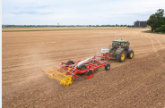 | 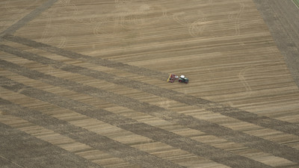
TERRIA with TEGOSEM | TERRADISC 6001 T with TEGOSEM
https://www.poettinger.at/de_at/newsroom/pressebild/102085 | https://www.poettinger.at/de_at/newsroom/pressebild/92055

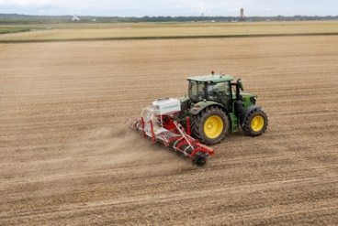 | 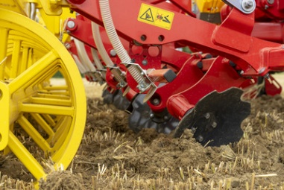
ROTOCARE V 6600 with TEGOSEM | TERRIA 4040 – Distribution plates for reliable spreading
https://www.poettinger.at/de_at/newsroom/pressebild/103002 | https://www.poettinger.at/de_at/newsroom/pressebild/101044
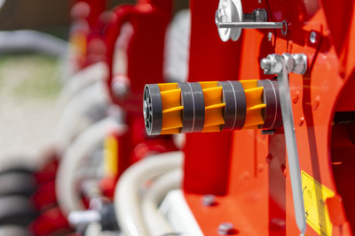 | 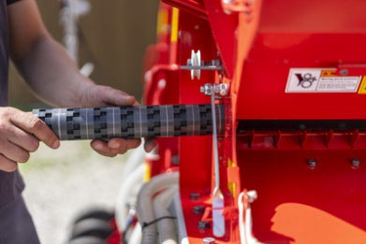
FOX 300 D, VITASEM M 3000 DD - Seeding shaft coarse dosing | FOX 300 D, VITASEM M 3000 DD – Seeding shaft fine dosing
https://www.poettinger.at/de_at/newsroom/pressebild/112336 | https://www.poettinger.at/de_at/newsroom/pressebild/111588
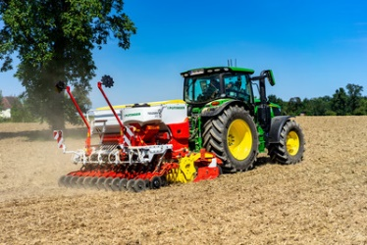

VITASEM M 3000 DD with FOX 300 D
https://www.poettinger.at/de_at/newsroom/pressebild/120936

More printer-optimised photos: http://www.poettinger.at/presse

