TERRASEM with the new Profiline comfort control system
Intelligent, efficient sowing with Pöttinger
TERRASEM seed drills combine efficiency with the highest level of flexibility and precision seed placement. In order to comply with feedback from the field in terms of making machines easier to use, the new Profiline comfort control system has been developed for universal seed drill technology.

Convenient operation
Profiline is the comfort control system that covers all the hydraulic functions of TERRASEM universal seed drills. The machines are supplied with oil by the tractor's load sensing connection, and all movements are controlled electro-hydraulically via a hydraulic block. The machine is operated by pressing a button on the control terminal or automatically by the task controller using Section Control and Variable Rate Control. All the tools are positioned automatically and precisely. The fan speed and coulter pressure are also controlled automatically.

Set precisely and saves time
During operation, the tools can be precisely adjusted to the site specific conditions. Independent of Section Control, the lifting and lowering sequences can also be set based on time or distance travelled. It is also possible to deactivate individual tools.
Intelligent control can be used to limit the vertical lifting height. Shorter lifting and lowering times allow faster turning times at the headland. Sensor monitoring enables the machine to fold and unfold automatically.

Headland control
The headland control function stops and restarts the machine precisely at the headland. Without a task controller, this function is controlled at the touch of a button. With a task controller, lifting and lowering is done automatically using the TC-GEO/TC-SC signals.

Task Controller Geo
Enabling Task Controller Geo and Section Control means that application maps can be used to operate the machine. The working depth of the disc harrow, coulter pressure and seed/fertiliser rates are then controlled automatically on a site-specific basis. This allows valuable resources to be used efficiently and saved as a result.
Pöttinger proves its expertise in digitalisation by making the TERRASEM models agrirouter-compatible.

Photo preview:
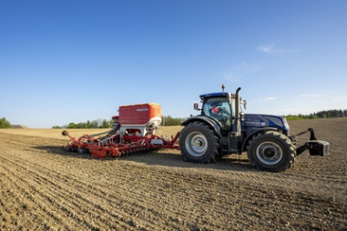 | 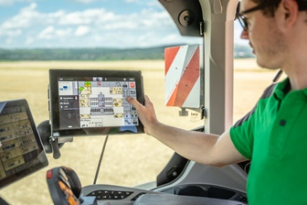
The TERRASEM V 6000 D Z with the new Profiline comfort control system for intelligent sowing | Intelligent, efficient sowing with the TERRASEM
https://www.poettinger.at/de_at/newsroom/pressebild/102523 | https://www.poettinger.at/de_at/newsroom/pressebild/102089

More printer-optimised photos: http://www.poettinger.at/presse

