Pöttinger: Mechanical, practical, good
VITASEM mechanical seed drills get a facelift
Proven technology meets user-friendly, practical features, all in the latest generation of mechanical VITASEM seed drills. The machines are available as simple linkage-mounted seed drills and with the suffix M (mounted) as implement-mounted machines.

Made for all conditions
True to the motto: "Mechanical, practical, good"; these machines are ready to handle the requirements of all sizes of farm and their specific on-site conditions. This is reflected in the possible working widths of 2.5 to 4.0 metres and also in the various machines they can be mounted on for seedbed preparation. The proven, versatile coulter systems ensure a neat seed slot for perfect seed placement in almost all operating conditions. Suffolk coulters, single disc coulters and double disc coulters are available. Different row spacings from 12 cm to 15 cm and coulter pressures from 25 kg up to 60 kg (new) cover all requirements, depending on the machine model and equipment options.

Optimum seedbed preparation
Different soil conditions and arable farming practices require a wide range of tillage implements for seedbed preparation. Optimised to match the different site conditions, there are drills suitable for FOX compact combinations and LION power harrows. The FOX is fitted either with harrow tines or discs to offer low draft operation. This enables higher driving speeds during sowing. The new LION power harrows available in the three different series lightweight, medium and heavy (LION CLASSIC, LION and LION MASTER) prepare the seedbed perfectly even under the most difficult conditions.

Generous seed hopper
Compared with the previous generation, the seed hopper volumes on all models have been increased by up to 25 percent. Capacity now ranges from 530 to 1,700 litres, depending on the model and equipment options. This ensures fewer filling intervals, shorter waiting times and ultimately an increase in output.
The opening is large enough to easily fill with big bags or tractor front loader. A wide support for sacks makes it easier to fill by hand. Ergonomically designed handrails are attached to the seed hopper for safe and convenient access. The wide platform provides an ergonomic and confident work environment.

Multi metering system
Grain-for-grain precision: Their unique seed metering system is the trademark of VITASEM seed drills. To cover a wide range of applications, two completely independent metering units are combined in one system. Both metering wheels are mounted on the same metering shaft. Two separate metering wheels in one system mean you can switch between normal seed and small seed metering in minutes without the need for tools. A choice of reducer inserts are provided to increase seeding variability even further.
The primary objectives of this technology are the exact setting of the required seed rates and optimised plant distribution density, both of which this proven system is able to support.

Practical operation
Everything on these machines is simple and convenient to operate from the left side of the machine. The calibration process and access to the loading platform are also catered for on this side.
Correct calibration is essential for uniform seed distribution and consequently for homogeneous emergence. Pöttinger makes the calibration process easier with numerous useful features to ensure that what you want to sow actually arrives at the seed coulter. Calibration is performed mechanically as standard by turning a calibration handle. Available as an option, an electric calibration system can also be installed on seed drills with mechanical metering. The motor saves cranking by hand and rotates at a constant speed.
A major advantage offered by this facelift is the clear view into the calibration trays. This means that the metering rate of each row can be seen and immediately readjusted if a metering unit is set incorrectly. The trays can either be removed conveniently from the side, or they can be removed from the access platform. This increases flexibility during the calibration process.

VITASEM M 3000 and VITASEM M 4000 implement-mounted seed drills are agrirouter-compatible with an optional electric metering drive.

Photo preview:
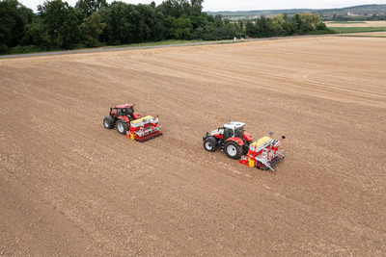 | 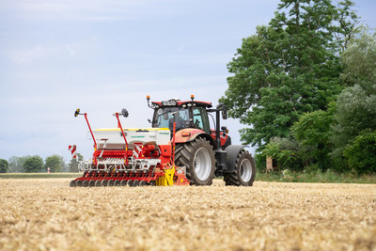
VITASEM M 3000 D mechanical seed drill for optimum seedbed preparation | Generous seed hopper increases output
https://www.poettinger.at/de_at/newsroom/pressebild/102542 | https://www.poettinger.at/de_at/newsroom/pressebild/102544

More printer-optimised photos: http://www.poettinger.at/presse

