Pöttinger PLANO shallow cultivator enters the coming season with new features

Heavy-duty tines, spiral spring tines, duck foot shares, wheel mark loosening tines
With its well-balanced frame and precision depth control, Pöttinger's PLANO shallow cultivator is perfect for mechanical weed control, erosion protection, seedbed preparation, medium-depth tillage down to 15 cm, and incorporating cover crops. A choice of tine systems, shares and additional tillage tools is available to match each application. In the coming season, the trailed shallow cultivator will receive new features and updates such as a heavy-duty harrow, spiral spring tines or track eradicators for even more versatile applications and an even better working result.
Heavy-duty tines for use without a rear roller
One of the most important new features is the heavy-duty tines that can be deployed instead of a rear roller. The tines are configured to form a three-row harrow that distributes plant residues and leaves behind a loose, non-consolidated soil structure. Weeds are sliced through and reliably deposited on the surface. Particularly efficient results are achieved by the heavy-duty tines when cultivating clover grass and other cover crops. Thanks to the quick-change system, the heavy-duty tines and rear roller can be swapped around in no time. The heavy-duty harrow is infinitely adjustable using hydraulics. A really practical feature: If blockages occur, they are easily cleared because the harrow can be folded to the rear hydraulically, from the cab, while driving.
Oscillating spiral spring tines for efficient soil cultivation
The new spiral spring tines see Pöttinger offer an alternative to the pre-tensioned tine. Spiral spring tines are perfect for light to medium-heavy soil types and for seedbed preparation. Their sweeping geometry allows high volumes of organic matter to pass through for particularly efficient soil cultivation. The oscillating effect also provides a finely crumbled tilth.
Also new on the PLANO are the wheel mark loosening tines, which are available as an option. These easily loosen tractor wheel marks during seedbed preparation without having to set the whole machine to a deeper working depth.
The wear-resistant DURASTAR PLUS duck foot shares now have a width of 220 mm.
The PLANO as a key element for integrated plant protection
The way the PLANO shallow cultivator from Pöttinger operates enables shallow, precise work between a depth of 3 and 15 cm, which saves resources and time. At a time when there are restrictions on using herbicides, and weeds are building up resistance, mechanical control strategies become unavoidable. That is why shallow tillage is a key component of modern arable farming systems.
With its six-gang configuration, 37 closely-spaced tines, and its new, application specific features, the PLANO is a decisive tool for integrated crop protection on smaller, family-run farms as well as for large-scale businesses.

Photo preview:
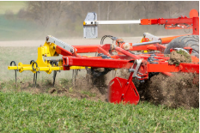 | 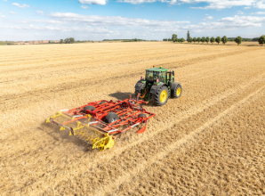
The PLANO trailed shallow cultivator gets new features | Whole surface movement despite shallow working depth
https://www.poettinger.at/de_at/newsroom/pressebild/182005 | https://mediapool.poettinger.at/pinaccess/showpin.do?pinCode=v9g3t5D2M8e7
More printer-optimised photos: http://www.poettinger.at/presse

