Annual report 2023/2024

Pöttinger stays strong against huge fluctuations in demand
Revenues consolidate at just under EUR 500 million

The Austrian family-owned company Pöttinger, headquartered in Grieskirchen, Upper Austria, maintained a strong position during the financial year 2023/2024 (reporting date 31 July) despite a challenging economic and geopolitical environment, and in relation to overall market developments. With an unchanged high export ratio of around 90 percent and a consistent share of the market, Pöttinger remains a highly relevant global player. Pöttinger machines are used by farmers and contractors all over the world. Following years of extreme growth (2021/22 up 25 percent, 2022/23 up 27 percent), revenue consolidated at EUR 491 million. Although there has been a clear decline in sales, Germany is still the highest profile market (18.2 percent of total sales in 2024), followed by France (17.1 percent) and Austria (10.4 percent). Other key markets include Switzerland, Poland, USA, Czech Republic, Italy, Great Britain, Ukraine, and Canada.

The best soil, the best forage
This value proposition sees Pöttinger put the needs of its customers first. From compact alpine implements to large-scale technology for primary tillage, seed drill technology, crop care machines, grassland harvesting and digital agricultural technology - in farming, delivering the best working results is what counts. Pöttinger machines make that happen. The most important sector in sales terms continues to be grassland technology, where Pöttinger received international recognition during the past financial year for innovations featured on its NOVACAT mowers, the MERGENTO F ALPIN alpine merger, and an important update to the HARVEST ASSIST app for optimising machine deployment during forage harvesting. For decades, Pöttinger has been the world market leader in loader wagons. Now, the BOSS 2000 ALPIN joins the long line of bestsellers.

Focus on arable farming
Grassland machines account for around two thirds of total sales. Pöttinger is working continuously and intensively to further extend its arable farming technology division. Another of the innovations launched during the past financial year is the new SERVO 3000 hitch-mounted reversible plough. New features and enhancements have also been made to the LION power harrows, the TERRASEM seed drill and the VITASEM seed drills. Being able to combine a TERRIA stubble cultivator and the TERRADISC 8001 T disc harrow with an AMICO F front hopper means that tillage, sowing and fertilisation can now be carried out in a single pass. Following Pöttinger’s acquisition of the Italian manufacturer MaterMacc in 2022, precision planter technology has now become established as an additional, successful product segment.

Spare parts up four million
Pöttinger’s "Original Spare Parts" division ensures a long-term supply of spare and wear parts at short notice, which is essential for agricultural businesses. Sales of EUR 65 million (up six percent on the previous year) is generated with around 118,000 deliveries per year.

Getting results is teamwork
As a family-owned company, Pöttinger stands for a team focus with good interaction between people. Everyone who works at Pöttinger is expected to take responsibility for their actions, development, work climate and results. The long-term success of the company relies on committed, competent and motivated employees. The company currently employs 2,216 people (50 more than the previous year) with 37 different nationalities. 1,266 employees work in Austria, 447 in the Czech Republic, 227 in Germany, with the others working at subsidiaries around the world. Pöttinger has 15 service centres and seven training centres that supply spare parts, support, training and service to customers in 85 countries on five continents.

The company strives to convey a strong feeling of partnership and integrity to its dealerships and suppliers, and in its work together with people in the global agricultural machinery trade. Pöttinger operates sales locations all over the world, as well as five production plants in Europe, two of which are in Austria (Grieskirchen and St. Georgen), and one each in Germany (Bernburg), the Czech Republic (Vodnany) and Italy (San Vito al Tagliamento).

Efficient and responsible
Pöttinger acts responsibly regarding the environment. The company takes every available opportunity to optimise the use of energy, avoid wastage and reduce waste. Each stage of product development reduces environmental impact compared to the previous model. In recent years, Pöttinger has invested strongly for more efficiency and sustainability. A whole series of measures have been implemented during the construction of the new plant in St. Georgen: A green roof system, a flowering meadow for bees, using wood as the main building material, energy-saving underfloor heating and LED lighting, the energy-efficient outer shell, and a biodegradable floor, are not only environmentally friendly, they also create a pleasant climate inside.

A sustainable business
During the financial year 2023/24, the whole of the agricultural technology industry suffered a downturn in expectations as a result of customers shying away from investment. Nonetheless, Pöttinger is going to grab this opportunity to implement strategic measures aimed specifically at aligning processes, optimising costs, and increasing efficiency within the company. The proven Kaizen principle is applied in a particularly effective way at Pöttinger: During the past financial year, Pöttinger employees made 7,493 improvements, enhancing the balance sheet by EUR 9 million.

Despite the challenging economic and geopolitical situation, Spokesperson for the Management Team, Gregor Dietachmayr, has a positive outlook: "We are continuing to develop our products, especially in the areas of crop care, arable farming and precision planter technology, and are working on new products to inspire our customers and impress them with our innovative creativity. Together with our employees, we will stay strong during these challenging times, and look to the future with optimism."

Photo preview:
 | 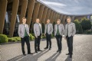
Gregor Dietachmayr,  Spokesperson for the Management Team | From the left: Wolfgang Moser, Gregor Dietachmayr, Jörg Lechner Herbert Wagner, Dr. Markus Baldinger
https://www.poettinger.at/de_at/newsroom/pressebild/73748 | https://www.poettinger.at/de_at/newsroom/pressebild/67368
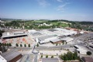 | 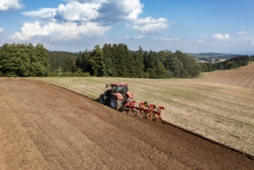
A bird's eye view of the headquarters in Grieskirchen (AT) | The SERVO 3000 PN: a reliable and well thought-out plough
https://www.poettinger.at/de_at/newsroom/pressebild/37826 | https://www.poettinger.at/de_at/newsroom/pressebild/110115
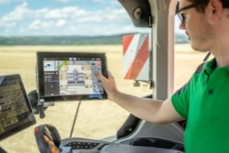 | 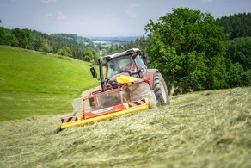
Focusing on arable farming: TERRASEM seed drill with the new Profiline comfort control system | Alpine merger matches the highest expectations: MERGENTO F 4010 ALPIN
https://www.poettinger.at/de_at/newsroom/pressebild/102089 | https://www.poettinger.at/de_at/newsroom/pressebild/97607

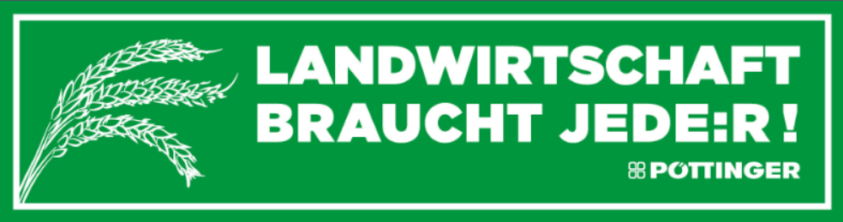
More printer-friendly photos are available at: https://www.poettinger.at/presse

