Pöttinger celebrates 25 years of sowing technology

A quarter century of innovation and precision
Pöttinger, a company previously focused on grassland machines, entered the arable farming sector by taking over the “Bayerische Pflugfabrik Landsberg” (Bavarian plough factory in Landsberg am Lech) in 1975. The next milestone followed 25 years ago in 2001, when the highly acclaimed Austrian company entered the sowing technology market by acquiring the Rabe seed drill plant in Bernburg, Germany.
Since then, Pöttinger has continuously expanded its range of seed drills. The mechanical VITASEM seed drills, the pneumatic AEROSEM seed drills, and the universal TERRASEM seed drills offer farming businesses new capabilities in precision sowing combined with optimum seedbed preparation.
Updates, new features, and awards
2003 - Pöttinger presents the TERRASEM at Agritechnica in Hanover and sets new standards with the mulch seed drill. 2009 – launch of the updated VITASEM mechanical seed drill for even more precise metering. 2012 - Pöttinger launches a direct fertilisation system on the TERRASEM seed drill. The new feature deposits nutrients exactly where they are needed, right next to the seed.
2013 - the new generation of AEROSEM seed drill wins the "Machine of the Year" award. The patented Intelligent Distribution System (IDS) delivers extremely precise seed distribution, while Precision Combi Seeding (PCS) integrates precision seeding technology into pneumatic seed drills. 2013 - Pöttinger also launches the FOX compact combination for even more seed drill flexibility.
2019 – 2021 see more new features added to the AEROSEM series. The AEROSEM F as a seed drill with a front hopper that achieves maximum output thanks to its pressurised hopper system. The AEROSEM VT joined the line-up. The trailed seed drill combination conserves the soil and is compact. These properties means that it perfectly matches the manoeuvrability of the whole series. 2022 – new to the product range, the AMICO front hopper with a choice of distribution systems for soil preparation implements, providing the optimum combination of tillage, fertilisation and sowing.
Takeover of MaterMacc for entry into precision planter market
2022 – Pöttinger takes over MaterMacc. The merger brings precision planters and integrated new technologies for modern arable farming into the Pöttinger product range.
Since the takeover, Pöttinger has successfully developed its San Vito location into a centre of excellence for precision planters. The PURO precision planter is the first joint development. It brings together MaterMacc's many years of experience with Pöttinger's agricultural engineering expertise and high quality standards.
The PURO sees Pöttinger open a new chapter that continues the company's 150-year family history, with the same mission as back then: To build machines that make farmers' lives easier, more efficient and more successful.

Photo preview:
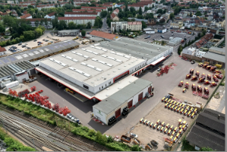 | 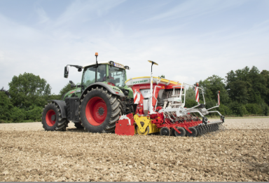
The seed drill plant in Bernburg | The latest AEROSEM 3002 ADD
https://mediapool.poettinger.at/pinaccess/showpin.do?pinCode=r3e8n9e0j9L8 | https://mediapool.poettinger.at/pinaccess/showpin.do?pinCode=P0b7a4V0P0T5
More printer-optimised photos: http://www.poettinger.at/presse

