Pöttinger celebrates 50 years of arable farming

Half a century of expertise in tillage and seed drill technology
Pöttinger Landtechnik GmbH entered the arable farming technology market in 1975 following the acquisition of Bayerische Pflugfabrik („Bavarian Plough Factory“) in Landsberg, Germany. 50 years and countless innovations later, the family-owned company based in Grieskirchen, Upper Austria, delivers impressive results based on solid expertise in grassland, digital agriculture, tillage, and seed drill technologies. Gregor Dietachmayr, Speaker of the Executive Board, emphasises the strategic importance of the arable farming segment for Pöttinger: "This dynamic market offers numerous opportunities and possibilities, which naturally, we are making full use of. We are working intensively on the continuous development of our arable farming technologies for the success of our customers, and for the long-term success of the company."
Acquisition of Landsberg plough factory
Founded in 1891, the “Bayerische Pflugfabrik” was one of the oldest manufacturers of soil preparation implements in Germany. With this strategic acquisition in 1975, Pöttinger acquired 85 years of experience as well as the expertise to develop high-quality arable farming machinery.
During the following years, Pöttinger launched numerous exciting innovations, such as the new SERVO generation of trend-setting ploughs (1988), the particularly rugged LION power harrows (1991) and the SYNKRO linkage-mounted stubble cultivator.
Bernburg seed drill plant – a milestone in the company's history
Purchasing the Rabe seed drill plant in Bernburg, Saxony-Anhalt, Germany, in 2001 marked the Pöttinger‘s entry into the seed drill technology market. The company expanded its arable farming portfolio to include mechanical, pneumatic and mulch seed drills.
More innovative new products followed, such as the TERRADISC compact disc harrow (2003) and the new generation of TERRASEM mulch seed drills (2004), which set new standards in tillage and sowing technology. In 2005, Pöttinger added to its product range the 3-row SYNKRO stubble cultivator, an implement that is suitable for both shallow and deep tillage. 2011 saw the launch of the updated VITASEM mechanical seed drill series featuring precision seed material metering and placement.
The TERRASEM mulch seed drill was expanded in 2012 to include direct fertilisation. In 2013, the new generation of AEROSEM pneumatic seed drills was awarded the "Machine of the Year" prize. 2020 saw the launch of the TERRIA stubble cultivator, while in 2021, crop care machines such as rotary hoes, row crop cultivators and tine harrows were added to the product portfolio.
MaterMacc: Entering the precision planter market
In 2022, Pöttinger took over MaterMacc. This company is based in San Vito al Tagliamento in northern Italy and is known for its expertise in precision planting technology, mechanical and pneumatic seed drills, crop care machines and other OEM components. The products, the company's passion for agriculture, the location and, above all, the dedicated people who work there, perfectly complement the Pöttinger family business.
At the same time, the AMICO flexible front hopper joined the Pöttinger family in 2022. In 2024, the PLANO was the first shallow cultivator to be added to the Pöttinger product range.
Anniversary year 2025: multiple reasons for celebration
The company's anniversary year 2025 brings numerous activities, retrospectives and, of course, special anniversary offers on arable farming equipment, crop care machines, grassland implements, and digital agricultural technology. The specially created anniversary website www.poettinger.at/go/50years-arablefarming with its various insights, retrospectives and outlooks is definitely worth a visit.

Photo preview:
 | 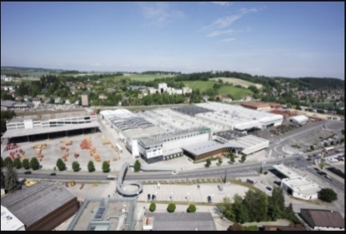 | 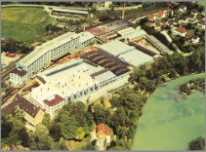
Gregor Dietachmayr, Speaker of the Executive Board | Grieskirchen – current photo | Bayerische Pflugfabrik Landsberg, 1975
https://www.poettinger.at/img/mediapool/assets/73748/3000/POETT_GF_korr240822_LK44-6948.jpg | https://www.poettinger.at/img/mediapool/assets/37826/3000/DSC03589.jpg | https://mediapool.poettinger.at/pinaccess/showpin.do?pinCode=M3y7Q1p2T0B9

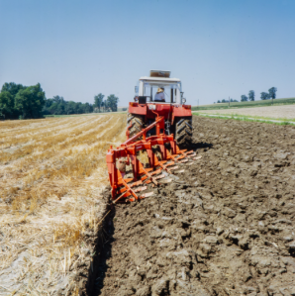 | 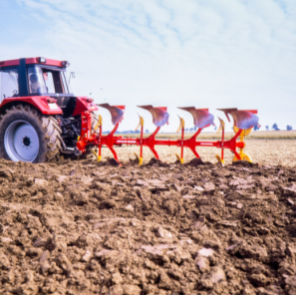 | 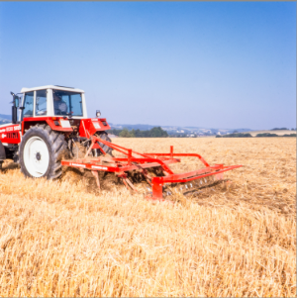
Landsberg Plough, ca. 1975 | SERVO III PLUS, ca. 1988 | SYNKRO 260, ca. 1991
https://mediapool.poettinger.at/pinaccess/showpin.do?pinCode=j4L2j8m4V4S9 | https://mediapool.poettinger.at/pinaccess/showpin.do?pinCode=U3v6o1L1E3v3 | https://mediapool.poettinger.at/pinaccess/showpin.do?pinCode=r7K5A9Q8g5S7

 | 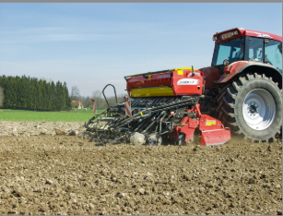  00 | 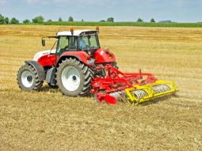
LION 3000, ca. 1991 | VITASEM A 301, ca. 2001 | TERRADISC, ca. 2003
https://mediapool.poettinger.at/pinaccess/showpin.do?pinCode=e2c3U2l1t8Y2 | https://mediapool.poettinger.at/pinaccess/showpin.do?pinCode=q6H1S7o6a4E3 | https://mediapool.poettinger.at/pinaccess/showpin.do?pinCode=T8P3X0Q2z5P8

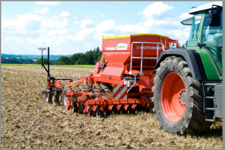 | 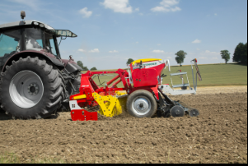 | 
TERRASEM 4000, ca. 2004 | FOX 300, 2013 | ROTOCARE V 6600, 2021
https://mediapool.poettinger.at/pinaccess/showpin.do?pinCode=D0K3C7B4I8B6 | https://mediapool.poettinger.at/pinaccess/showpin.do?pinCode=e9Y2x7E3d5z6 | https://mediapool.poettinger.at/pinaccess/showpin.do?pinCode=v4A2D2d4H1y6

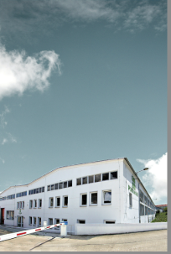 | 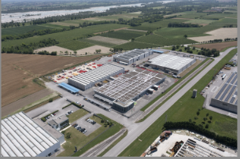 | 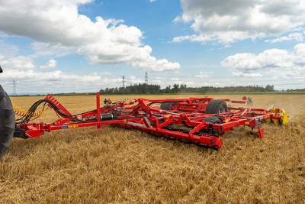
Bernburg, 2010 | MaterMacc – San Vito | PLANO, 2024
https://mediapool.poettinger.at/pinaccess/showpin.do?pinCode=E0D4n7E7G4m1 | https://mediapool.poettinger.at/pinaccess/showpin.do?pinCode=U3M9k6G1A0X3 | https://www.poettinger.at/de_at/newsroom/pressebild/152855

More printer-optimised photos: http://www.poettinger.at/presse

