Even more efficient harvesting: Automatic swath placement on NOVACAT V mowers

Digital upgrade available in the coming season
Pöttinger gave a sneak peek of the new automatic swath placement system at Agritechnica 2025. The digital upgrade to NOVACAT V 10000 ED/RC COLLECTOR mowers will finally be available in the coming season. Automatic swath placement ensures that these mower combinations with a cross conveyor belt always deposit the forage correctly. Merging swaths to one side of the machine - intelligent mowing - is more efficient and easier than ever before.
Around 40 percent less raking work, lower fuel consumption, better utilisation of harvest machinery because there is more forage in each swath, all of which lead ultimately to much more cost effective harvesting. What is more, skipping lanes enables larger turning circles at the headland, which reduces damage to the sward.
Previously, swath merging systems were a challenge for the drivers because they had to keep switching the cross conveyor belt manually. The automatic swath placement system from Pöttinger automatically switches the cross conveyor unit depending on which lane is being mowed. The result: The forage is always placed correctly, significantly reducing the risk of operator errors. Drivers can focus fully on the machine and the surroundings, clearly reducing fatigue.
If the machine is equipped with Pöttinger Connect, the mowing pattern is intuitively displayed on the map in the HARVEST ASSIST app. This means that the drivers always have a complete overview to efficiently plan their working day.

Photo preview:

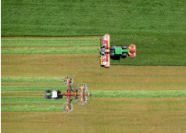 | 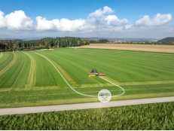
Automatic swath placement is available in the coming season | Intelligent mowing is easier than ever before with automatic swath placement
https://www.poettinger.at/de_at/newsroom/pressebild/179386 | https://www.poettinger.at/de_at/newsroom/pressebild/180339

More printer-optimised photos: http://www.poettinger.at/presse

