BOSS 2000 ALPIN:
Pöttinger sends new loader wagon onto the slopes
Alpine terrain demands the best from technology. Steep slopes, uneven terrain and huge differences in elevation, these are the operating conditions that Pöttinger knows very well being based in Austria. The ALPIN range of equipment is continuously being adapted to meet these demands even better. With the BOSS 2000 ALPIN, Pöttinger now presents the latest revision to the BOSS ALPIN series. The central element of the three new models is the 1.80 metre wide pick-up, which they inherited from their big brother, the BOSS 3000. In addition to a modern design, the BOSS loader wagons have also been equipped with new on-board electronics. The BOSS 2000 ALPIN is available in three sizes with DIN loading volumes of 13.50 m², 16.10 m² and 18.70 m²: BOSS 2140 ALPIN, BOSS 2160 ALPIN, BOSS 2190 ALPIN.

Maximum stability on slopes
BOSS 2000 ALPIN models are purpose-built, low-profile loader wagons. With a track width of 2.09 m, the tyres are wider than the body for maximum stability. In addition to AS profile, tyres up to 520 mm wide can be fitted. Mudguards are available as an option. These are at an angle so that dirt cannot accumulate. Thanks to the welded frame design, BOSS ALPIN loader wagons are particularly lightweight.

Wide pick-up
The pick-up has an effective width of 1800 mm (DIN) and its freedom of movement has been greatly improved. In especially demanding terrain, a trailing jockey wheel chassis contributes to a cleanly collected crop. Ground tracking can also be optimised with the AUTOTAST active parallel lift drawbar. The five tine carriers, which are guided by a cam track, are driven by a maintenance-free V-belt. A crop swath roller and flexible transfer plates are standard and ensure a perfect flow of forage with any type of crop.

SUPERMATIC loading unit
Maximum forage conservation with low power requirements are key characteristics of the SUPERMATIC tine conveyor unit. As standard, the BOSS 2000 ALPIN has a 6-knife chopping system. A maximum of 16 knives can be installed. Each knife is equipped with its own individual protection system, At headlands, the loading unit and pick-up switch off automatically. This means that the loader wagon can be driven over swaths without disturbing them, while the tractor's full power is available for turning around.

Configured especially for small tractors
BOSS ALPIN loader wagons can be operated with as little as 40 horsepower and a PTO speed of 540 rpm. Just one double-acting and one single-acting remote with open centre are all that are needed to operate the loader wagon. This means that it can be used with older and/or smaller tractors. The drawbar can be attached to the tractor using a hammerstrap, the lower linkages, or a low K80 ball hitch. A drawbar extension enables operation with tractors fitted with wide tyres or dual wheels.

The right control terminal for every operator
The standard system supplied with the BOSS 2000 ALPIN includes a BASIC CONTROL terminal. This enables the operator to preselect the functions for the pick-up and tailgate so they can be carried out using a spool valve on the tractor. An LED indicates whether the tailgate is open or closed. The optional hydraulic parallel lift drawbar can be operated using an additional spool valve. The higher specification control terminals bring ISOBUS capability to the BOSS 2000 ALPIN. Optional functions such as the parallel lift drawbar and the hydraulic dry forage extension are integrated into the control system. With the top version, the loader wagon can also be operated using a power beyond or load-sensing hydraulic circuit. In this case, all functions can be performed directly from the control terminal.

As the world market leader in loader wagons, Pöttinger once again demonstrates its outstanding expertise in forage harvesting in flat and alpine regions with the BOSS 2000 ALPIN series.

Photo preview:
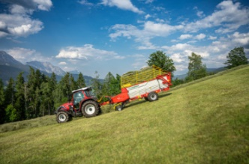 | 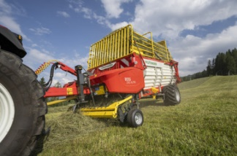
The BOSS 2160 LP ALPIN cuts a fine figure on steep slopes | BOSS 2160 LP ALPIN, featuring a tine conveyor loading unit for harvesting the best quality forage
https://www.poettinger.at/de_at/newsroom/pressebild/100065 | https://www.poettinger.at/de_at/newsroom/pressebild/99950

More printer-friendly photos are available at: https://www.poettinger.at/presse

