The highest accolade for Klaus Pöttinger

Award of Merit in recognition of outstanding achievements in agricultural technology
Klaus Pöttinger - one of the owners of PÖTTINGER Landtechnik GmbH - was Technical Director of the company from 1991 to 2016. It was under his management that flagship projects were developed, and he played a major role in leading the company to global relevance. Klaus Pöttinger received the Award of Merit from the European Society of Agricultural Engineers (EurAgEng) in recognition of his achievements.
Klaus Pöttinger is responsible for numerous innovations at PÖTTINGER, including digital farming technology and innovative manufacturing methods. These include the JUMBO loader wagon - a revolutionary bestseller which, with its EASY MOVE swing-out knife bank, the JUMBO COMBILINE (combined silage wagon and harvest transport trailer), and the AUTOCUT automatic knife sharpening system, still delivers the highest output, reliability and the best forage even after a quarter of a century. Klaus Pöttinger's commitment to ISOBUS in the early 2000s makes him a pioneer of digital farming technology. In manufacturing, he introduced flexible working methods and continuous improvement processes. The construction of the Technology and Innovation Centre was also during his leadership. The Technology and Innovation Centre was one of the first in-house test centres in agricultural technology. Since its opening in 2004, it has carried out simulations and produced virtual prototypes, as well as tested machines in real operating conditions.
The Award of Merit is presented every other year to outstanding people in the industry who have achieved international recognition and commercial success for their contribution to technical innovation in agricultural engineering. Klaus Pöttinger accepted the award in front of an audience of international experts at the LAND.TECHNIK AgEng 2025 international agricultural technology conference on 7 November in Hanover.
Photo preview:

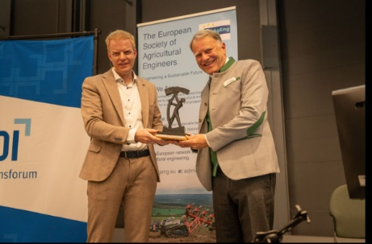 | 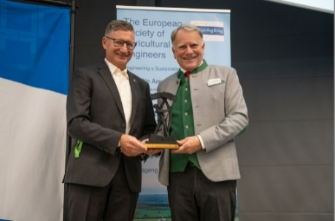
Klaus Pöttinger receives the den „Award of Merit“ from laudator Boris Kettelhoit | Markus Baldinger (Managing Director research and development PÖTTINGER Landtechnik) congraturates
https://mediapool.poettinger.at/pinaccess/showpin.do?pinCode=A2r2t4p9l2t7 | https://mediapool.poettinger.at/pinaccess/showpin.do?pinCode=K5c8P0z8d2J9

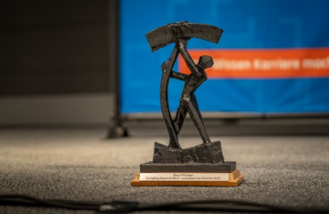  Bildvorschau | 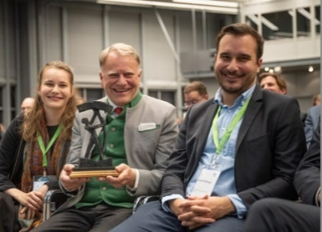
The Award | Klaus Pöttinger and his children Susanne und Richard bei der Preisverleihung in Hanover
https://mediapool.poettinger.at/pinaccess/showpin.do?pinCode=c4Q8N6e8p8Y5 | https://mediapool.poettinger.at/pinaccess/showpin.do?pinCode=Y2e5D6y8H2Q4

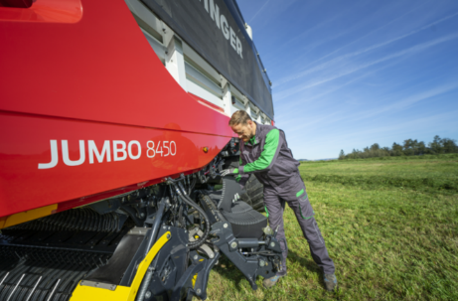 | 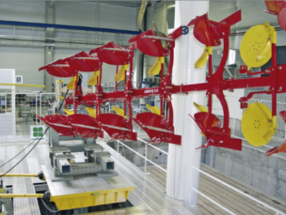
Proven JUMBO Produktfeature since 1999: swing-out knife bank | State-of-the-art testing methods in TIZ (Technology and Innovation Center)
https://mediapool.poettinger.at/pinaccess/showpin.do?pinCode=c3m3F7y0h3C4 | https://mediapool.poettinger.at/pinaccess/showpin.do?pinCode=g5s8e8Y2s0o3

