Annual report 2024/2025

Pöttinger: A good result despite challenges

Grassland increases market share, revenues up again in multiple markets and in spare parts
Despite a multitude of global challenges in the agricultural machinery industry, Pöttinger Landtechnik GmbH in Grieskirchen (Upper Austria) delivered a solid result in the financial year 2024/25 (reporting date 31 July). Unprecedented economic, political, and environmental factors made business planning more difficult, although the planned level of revenue was in fact achieved. What is particularly pleasing is the increase in market share in the grassland segment.
Years of extreme growth (2021/22 up 25 percent to around EUR 506 million, 2022/23 up 27 percent to around EUR 641 million) were followed by a period of reluctance to purchase due to full warehouses at dealerships and other investments being brought forward. Following up from EUR 491 million in the previous year, revenue in the financial year 2024/25 is around EUR 461 million (down 6 percent). Key sales markets such as Germany and France are slowly beginning to stabilise, with some countries showing significant growth in sales in many segments.

A leading global agricultural machinery brand
Around 57 percent of machinery sales is achieved in Germany, France, Austria, Poland, Ukraine, and Switzerland. The export ratio has remained stable for many years at around 90 percent.
The ability to supply spare parts quickly is a decisive success factor for farming businesses of all sizes. That is why the ORIGINAL PARTS division is so important for Pöttinger. With 15 of its own service centres and countless service partners, Pöttinger reliably supplies customers on five continents with spare parts, service support, and training.

Sustainable and appreciative cooperation
The strong fluctuations in demand over recent years have made production scheduling a challenge. As in the previous year, the period of low manufacturing utilisation in the summer was also bridged in financial year 2024/2025 by short, temporary leave for employees in production. Thanks to these and other human resources measures, such as not filling positions that became vacant due to natural fluctuation and reducing the amount of accrued vacation time, Pöttinger has been able to retain most of its permanent employees. The workforce currently consists of around 2,100 employees from 36 nations. Around 1,200 work in Austria, around 400 in the Czech Republic, around 200 in Germany, around 80 in Italy, and the remaining 200 work at Pöttinger subsidiaries around the world.
The company's principles of partnership and sustainability are also reflected in the average length of employment of 11.7 years, which is well above the Austrian average.
In terms of the economy and the environment, the company is also committed to sustainability and maintaining its responsibility. Recent years have seen significant investments in conserving resources and the environment. As a family business, Pöttinger has been deeply rooted in its local surroundings since 1871.

Partnership and authenticity
Pöttinger manufactures state-of-the-art agricultural machinery at five production sites and, as a result, makes an important contribution to ensuring food security for the world's population. Two manufacturing sites are located in Austria (Grieskirchen and St. Georgen bei Grieskirchen), one is in Germany (Bernburg), one is in the Czech Republic (Vodňany), and one is in Italy (San Vito al Tagliamento). Pöttinger's innovative machines are sold worldwide through agricultural machinery dealerships. Employees, dealers, and suppliers act as a team, working together to achieve success together.

Agricultural technology for successful farming
Pöttinger is a pioneer of digital agricultural technology and manufactures intelligent, networked machines for efficient, successful farming. Grassland technology is still the most important segment, accounting for around 55 percent of total sales. The JUMBO 5000 is a powerful high-performance loader wagon that Pöttinger launched on the market during the last financial year. The new HIT V ALPIN tedder is ideal for working on steep ground. With the TOP VT 6820 S and the TOP VT 12540 C, Pöttinger has developed a reliable twin-rotor rake and a compactly designed four-rotor rake. Among the mowers, the NOVACAT F OPTICURVE turned heads. The automatic, arc-path side shift won Pöttinger the AgrarTech Gold award.
In the tillage and seed segment, the AEROSEM VT and AEROSEM FDD are innovations in seed drill technology. While the SERVO 2000 and SERVO 4000 are two new ploughs that have been launched on the market. The new FOX 3000 D disc harrow and the new LION V 6040 6-metre-wide power harrow are the latest seedbed preparation machines. The PLANO VT 6060 sees Pöttinger enter the shallow cultivator segment. In sowing technology, the development of precision seed drills is progressing with innovations on board the AEROSEM series of pneumatic seed drills. With its extensive product portfolio and the promise of "the best working results", Pöttinger remains a strong partner for successful farming.
"The past financial year, with its crises and uncertainties, has asked everybody at Pöttinger to go above and beyond. That is why each success counts all the more: Together as a strong team, we have been able to meet our target, and in the grassland segment we have managed to increase our market share in the face of tough competition. You can really see that our innovative strength, partnership, a sense of responsibility, and sustainable business practices are paying off," says Gregor Dietachmayr, Speaker of the Executive Board, satisfied with the result of financial year 2024/2025, despite the general downturn in revenues.

Photo preview:

 | 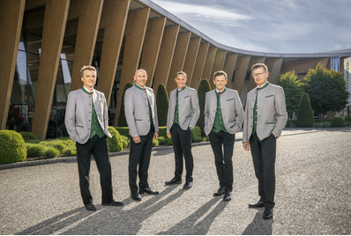
Mag. Gregor Dietachmayr,  Speaker of the Executive Board | The Executive Board: Mag. Wolfgang Moser, Gregor Dietachmayr, Jörg Lechner Herbert Wagner, Dr. Markus Baldinger
https://www.poettinger.at/de_at/newsroom/pressebild/73748 | https://www.poettinger.at/de_at/newsroom/pressebild/67368

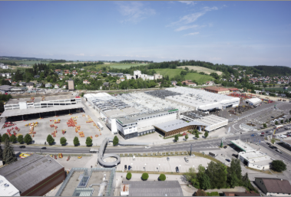 | 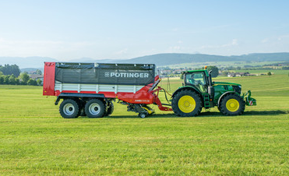
A bird's eye view of the headquarters in Grieskirchen (AT) | The high-performance JUMBO 5370 DB loader wagon
https://www.poettinger.at/img/mediapool/assets/37826/3000/DSC03589.jpg | https://www.poettinger.at/de_at/newsroom/pressebild/129487

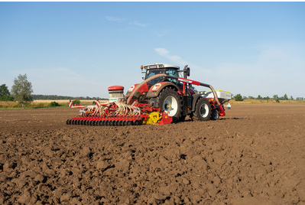 | 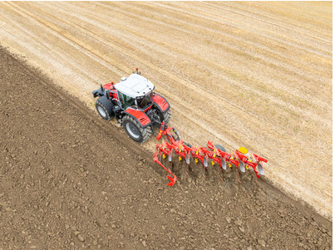
The AEROSEM 5002 FDD seed drill combines high output with convenient operation | The cost effective SERVO 4000 plough
https://www.poettinger.at/de_at/newsroom/pressebild/41245 | https://www.poettinger.at/de_at/newsroom/pressebild/153755

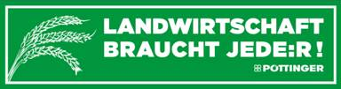
More printer-friendly photos are available at: https://www.poettinger.at/presse

