Pöttinger test centre with new capabilities
The Technology and Innovation Centre TIZ Landl Grieskirchen (AT), which has Pöttinger as one of the main tenants, has completed a second phase of expansion. Due to the good order situation, the new hall, TIZ 3, was able to start operation in February 2023.

The latest testing equipment right from the start
The Technology and Innovation Centre was founded in 2002. There are three shareholders who each hold one third of the shares: a group of three local municipalities (Grieskirchen, St. Georgen, and Tollet), Pöttinger Landtechnik GmbH, and the location agency Business Upper Austria. TIZ Landl and Pöttinger as the lead company are running a state-of-the-art research and testing centre in close cooperation. Over the years, the centre has gained an excellent reputation internationally. The Pöttinger test centre offers prototype construction, testing, measurement and inspection technology. The latter is used not only for Pöttinger’s agricultural machinery, but also for running pilot projects for external customers in cooperation with TIZ Landl GmbH. During development of agricultural machinery the test centre has the task of generating knowledge for the transfer to series production and collaborating with testing companies to guarantee the best possible working result. Additionally, durability testing is carried out on the test beds that covers the full service life under operational conditions such as those found in the field.
The new part of the building (TIZ 3) increases capacity and provides 1,800 m² of additional floor space. 1,300 m² of this is dedicated to testing technology, with the remainder for prototyping. The equipment includes a 360-m² component testing station for individual test bed set-ups both for customers of TIZ Landl GmbH and Pöttinger agricultural machinery. The testing cylinders are supplied with power by a hydraulic power unit with an output of 400 kW. Two 10-tonne cranes are able to lift fully assembled machines onto the test bed set-up. On the first floor there are modern offices and meeting rooms on 500 m² of floor space where the Pöttinger and TIZ Landl GmbH testing engineers work closely together on running and planning the testing projects.
The TIZ Grieskirchen houses the most modern component testing equipment in Europe. Pöttinger uses it to run intensive testing of its agricultural machines. TIZ Landl GmbH also performs testing jobs for third-party companies from many different countries which benefit from the testing expertise in agricultural technology. In particular, the new extension adds a workload test bed for comprehensive analysis of entire machines. It also provides access to test scenarios for e-mobility including testing of high-voltage components. Markus Baldinger, Pöttinger Managing Director explains the motives: "In addition to investing in our modern production plants, we have a strong focus on the possibilities for testing and inspecting our agricultural machinery. This additional investment in TIZ 3 sees us fulfilling our promise to our customers regarding high quality, strength, reliability and durability." The tests that simulate real operating conditions save up to 75 per cent of the time and costs compared to practical tests performed in the field. The result is that there is now plenty of new space created in one of the most modern component testing centres in Europe to offer even more capabilities.
"Our technology stands for the best working results. We aim to deliver the highest quality, reliability and durability. With the additional hall and the latest technology, we can offer our customers even more. Now that we can perform e-mobility testing, we are right up to date in attracting new companies through TIZ Landl GmbH", says Markus Baldinger, confident of the latest expansion phase's success. The new offices also offer attractive workplaces in a high-tech environment.

Photo preview:

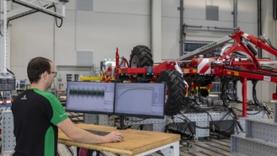 | 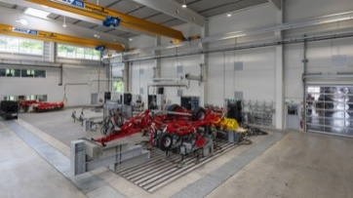 | 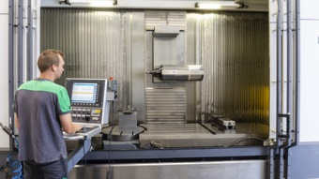
Durability test covering the full service life | Modern environment for innovative component testing | Prototyping is a central task at TIZ 3
https://www.poettinger.at/de_at/newsroom/pressebild/102116 | https://www.poettinger.at/de_at/newsroom/pressebild/102114 | https://www.poettinger.at/de_at/newsroom/pressebild/102130

