25 years JUMBO: Loader wagon from world market leader Pöttinger celebrates its anniversary

The very first JUMBO was presented to the world in 1999 – a revolution in the agricultural machinery market. At the time, the JUMBO was regarded as "the new dimension in large-capacity silage wagons" and was the first and only system to stand up to the emerging field chopper. The JUMBO stood for efficiency, performance, top forage quality, operational reliability, economy, comfort and easy maintenance. And it was the first machine at Pöttinger to be designed entirely with 3D CAD. JUMBO inventor Pöttinger is now the world market leader in loader wagons. With a stable export quota of around 90 per cent, the company from Grieskirchen is a highly relevant global player.
A quarter of a century of JUMBO – that's 25 years of experience and development, which has resulted in numerous sensational innovations. An absolute novelty on the loader wagon market was the option for short-chopping the crop. The JUMBO 8000 model was the world's first 25-millimetre harvester wagon. Other innovations include the EASY MOVE swing-out knife bank, which ensures ergonomic working. The JUMBO beater rotors is used to loosen the crop. The fully automated AUTOCUT knife sharpening system ensures consistent cutting quality throughout the entire working day. The pick-up is responsible for the clean and tidy collection of the crop. The once rigid front panel of the JUMBO 1000 has now become an intelligent, movable front panel. While the JUMBO was designed for tractors with up to 280 hp in 1999, the 7000 and 8000 series can be powered by tractors with a maximum of 500 hp.
The JUMBO has always been a guarantee for the best forage. As a favourite on farms and with contractors, it has dedicated fans around the world – even outside of agricultural work. In the Pöttinger fan shop, it's not just T-shirts and caps for young and old that are very popular. The loader wagons in toy format, the JUMBO pedal tractor trailer for kids and many other elefantastic fan articles are also in great demand.

Have a look at the JUMBO anniversary video under the following link:
https://youtu.be/AkjMDKf4Ta4
You can find lots more information and videos on the JUMBO anniversary website at www.poettinger.at/jumbo25

Photo preview:
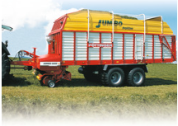 | 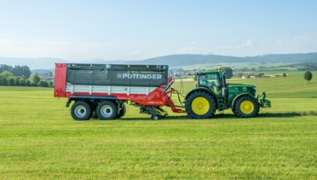 | 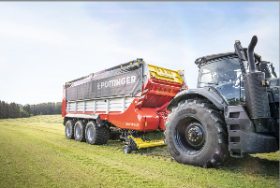
This is what the JUMBO looked like in 1999, the year it was born | The latest member of the loader wagon family: the compact and powerful JUMBO 5000 | The largest and most powerful of the family: The JUMBO 8000
https://mediapool.poettinger.at/pinaccess/showpin.do?pinCode=z3N0l7y8P9F0 | https://mediapool.poettinger.at/pinaccess/showpin.do?pinCode=r5Y8P5Z9g1D3 | https://mediapool.poettinger.at/pinaccess/showpin.do?pinCode=i4v2n4h5j9I5

More printer-optimised photos: www.poettinger.at/presse

