The latest Pöttinger innovation: The multi-purpose LIQUIDO F silage additive tank

Precision application of inoculant solution for high-quality silage
LIQUIDO F is the newly developed, versatile front silage additive tank from PÖTTINGER. It can be used easily and flexibly in combination with a wide variety of different brands of loader wagons and balers. The nozzle header is positioned between the pick-up and the rotor, where it applies the lactic acid bacteria solution directly and homogeneously to the flow of forage to produce high-quality silage. The application rate is matched to the flow of forage and the farm's requirements.
The LIQUIDO F can also be used as a front bumper and as front ballast. Maximum utilisation of this versatile and cost-effective unit is a given because it covers such a wide range of different applications.
Two models to meet different requirements
The silage additive tank is available in two versions: LIQUIDO F 2000 and LIQUIDO F 3000 The LIQUIDO F 2000 has an application rate of 40 l/h to 245 l/h, while the premium LIQUIDO F 3000 can be expanded to achieve up to 470 l/h by adding two more nozzles.
A digital flowmeter measures the application flowrate in litres per hour. The flowrate can be easily adjusted using the + 10 % / - 10 % button.
On the LIQUIDO F 3000, the flowmeter regulates the application rate automatically according to the defined target rate and the current operating conditions. It switches on the two additional nozzles automatically when required.
The way the application rate is to be controlled is selected before each job: It can be switched on and off manually at the touch of a button, or automatically according to the position of the pick-up: it switches off when the pick-up is lifted so that no silage additive goes to waste. An additional option on the premium LIQUIDO F 3000 model controls the application rate according to the driving speed: the higher the speed, the more silage additive is applied to the flow of forage.
Compact, versatile, practical
The LIQUIDO F has three tanks for quick and easy handling. The main tank, the fresh water tank, and a hand washing tank enable several work steps at once, from mixing to filling and hand rinsing. The main tank has a standard size of 200 litres, but is also available in a 400-litre version.
Cleaning the tank, the supply lines and the nozzles is also extremely easy with this ingenious concept. Thanks to the fresh water tank (the LIQUIDO F 3000 even has an integrated cleaning nozzle), the cleaning process is completed in just a few steps, so the LIQUIDO F is soon ready for its next job.
Other practical features that round off this versatile unit include a level indicator, jaw hitch, and toolbox. Work area lights and storage rollers are available as options.
When used as a front bumper, the LIQUIDO F enhances safety on the road with its clearly visible lighting. Its width can be adjusted between 2.55 and 2.85 m, and it can also be used as front ballast. Fulfilling a versatile range of applications, the multi-purpose LIQUIDO F from Pöttinger is perfect for farms of all sizes.

Photo preview:
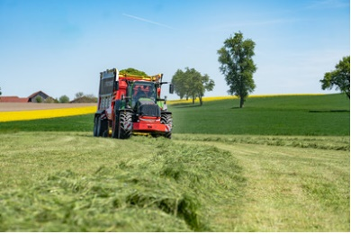 | 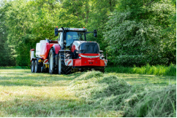
LIQUIDO F 3000 in action with JUMBO 5320 DB | LIQUIDO F 3000 i action with IMPRESS 3160 VC PRO
https://www.poettinger.at/de_at/newsroom/pressebild/171372 | https://www.poettinger.at/de_at/newsroom/pressebild/170833
More printer-optimised photos: http://www.poettinger.at/presse

