New: MERGENTO F ALPIN merger
Tradition and haymaking in the Alps - two concepts that have shaped Pöttinger's history. In 1960, the legendary conveyor rake revolutionised haymaking in the mountains. Today, the grassland specialist sets another milestone in steep terrain mechanisation with the MERGENTO F 4010 ALPIN. With a DIN working width of 4.00 metres, the merger rakes a perfect swath, even on steep terrain.

The best forage
The MERGENTO F ALPIN delivers extremely clean raking quality. The merger collects the forage from the ground using its controlled pick-up. Without further contact with the ground, the cross conveyor belt transports the forage to the swath. This results in two major advantages:
- Dirt and stones remain on the ground because they are not contacted by the pick-up tines.
- Disintegration losses are reduced to a minimum because the forage is not raked across the ground. This is an advantage especially with dry hay.

Enhanced safety on steep ground
The alpine front belt merger from Pöttinger is a real lightweight. A weight of just 575 kilograms and a pick-up width of 3.08 metres give you reliable operation on steep slopes. The crop press roller with baffle curtain and the cross conveyor belt being 77 millimetres lower than the pick-up transfer point also contribute to maximum effectiveness in alpine terrain. This guarantees perfectly shaped swaths and reliable operation even when driving downhill.

Three glide bars follow the ground to guide the merger over every undulation. The newly developed comb skids are positioned directly at the point of tine engagement. This virtually eliminates damage to the sward and keeps the forage clean. The belt unit is suspended centrally. Centre-mounted leaf springs provide a freedom of movement of +/- 8 degrees. This allows the merger to adapt perfectly to any bumps in the ground, regardless of the inclination of the tractor.

The best flexibility
The MERGENTO F 4010 ALPIN delivers unique flexibility. The speed and direction of rotation of the cross conveyor belt can conveniently be set from the cab. As a result, the following swath configurations are possible:
- Placement to the left
- Placement to the right
- Collect forage on the belt
This brings enormous advantages, especially on mountain farms: The MERGENTO F 4010 ALPIN can be used to collect crop around any obstacles, awkwardly shaped fields, and steep slopes that cannot be accessed by the harvesting vehicle.

Reliability
MERGENTO F 4010 ALPIN wins the day due to its extreme robustness, despite its lightweight and compact design. Both the pick-up and the cross conveyor belt are driven hydraulically. They are powered either by the tractor hydraulics, or by an optional rear-mounted hydraulic unit. This enables an extremely compact configuration and the best weight distribution on the tractor.

The new mountaineer in the Pöttinger merger range stands for the highest forage quality even in areas that are difficult to access, and on steep slopes.

Photo preview:
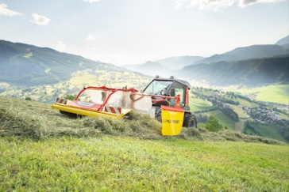 | 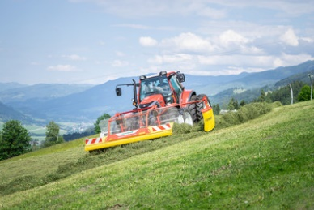
The new front-mounted MERGENTO F 4010 ALPIN merger | The new MERGENTO works perfectly on steep terrain
https://www.poettinger.at/de_at/newsroom/pressebild/99749 | https://www.poettinger.at/de_at/newsroom/pressebild/99750

More printer-friendly photos are available at: https://www.poettinger.at/presse

