New: NOVACAT F 3100 OPTICURVE
Pöttinger front mower with automatic curved side shift
Careful mowing forms the basis for high quality forage. Pöttinger mowers meet the demand for optimum ground tracking, low disintegration losses and precision operation without time-consuming adjustments. Now the grassland specialist has launched a new technology featuring automatic curved side shifting on the NOVACAT F 3100: This side shift system on the front mower guarantees a perfect overlap with the rear mower and ensures the tractor drives along a clear track free of forage when cornering and working on steep ground. The curved movement means that the entire working width of the cutter bar can be used and the effective width of the mower combination maximized. Systems with straight-line side shift leave several centimetres uncovered.

Clean and tidy cut
Even if the tractor drifts sideways when cornering or on steep terrain, the rear tyre of the tractor does not run over grass that has not been cut yet because the mower shifts towards the inner radius of the curve. What is more, no forage is left behind because the front mower overlaps perfectly with the rear mower.

Convenience:
An optional ISOBUS automation package controls the sideshift of the mower automatically depending on the turning angle of the tractor or the inclination of the slope to the left or right. This means that the driver's workload is significantly reduced because no intervention is required. The result: maximum convenience.

Special advantages
A special advantage of this new technology is the ability to detect changing degrees of overlap between the front mower and the tractor or rear mower(s) and respond automatically. No grass is driven over or left standing, either when cornering or on steep ground. Harvesting machines that come to collect the forage can operate without any problems and there is no old crop left behind for the next cut. Automatic mode allows the operator to concentrate on driving the tractor and their surroundings. The process is also sustainable: Fewer turning manoeuvres being needed in the field/meadow create less pressure on the ground while bringing about greater efficiency by saving time, and a reduction in driver fatigue because fewer interventions are required.

Photo preview:
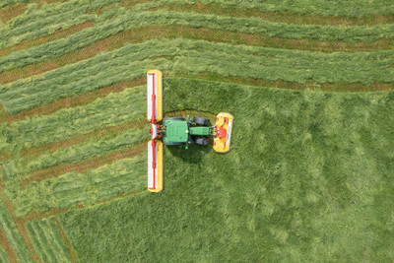 | 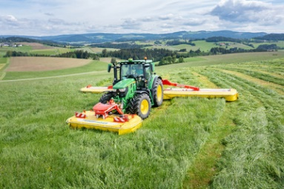
NOVACAT F 3100 OPTICURVE,  NOVACAT H 11200 | NOVACAT F 3100 OPTICURVE,  NOVACAT H 11200
https://www.poettinger.at/de_at/newsroom/pressebild/135624 | https://www.poettinger.at/de_at/newsroom/pressebild/135622

More printer-optimised photos: http://www.poettinger.at/presse

