New feature for award-winning Pöttinger front mower

NOVACAT F 3100 OPTICURVE now with Profiline comfort control system
The NOVACAT F 3100 OPTICURVE was already a sensation when it was launched in 2024. Now the front mower, which won an AgrarTec Gold medal, has received a decisive upgrade: In the coming season, it will be available with the Profiline comfort control system as an option.
With the Profiline comfort control system, the mower steers left and right automatically depending on the turning angle of the tractor and the inclination of the slope. The information needed to do this is provided by an acceleration sensor installed directly on the mower. By including the tractor's turning angle signal, the accuracy of the calculation increases even further.
The mower is controlled either using the tractor's ISOBUS terminal or a SELECT CONTROL terminal. Hydraulic oil is supplied by a load-sensing or power beyond system.
The special advantages of the side shift system
The side shift system is really noticeable when cornering and on slopes because it provides a perfect overlap with the rear mower and ensures the tractor drives along a clear track free of forage. The curved movement means that the entire working width of the cutter bar can be used and the effective width of the mower combination maximised. By contrast, systems with straight-line side shift leave several centimetres uncovered in this situation.
A special advantage of this technology is the ability to detect changing degrees of overlap between the front mower and the tractor or rear mower(s) and respond automatically. No grass is driven over, and no feathers are left standing, neither when cornering nor on steep ground. And, because there is no old crop left behind for the next cut, the follow-up harvesting machines can work undisturbed. Thanks to automatic mode, the operator can focus on driving the tractor while keeping an eye on the surroundings.

Photo preview:
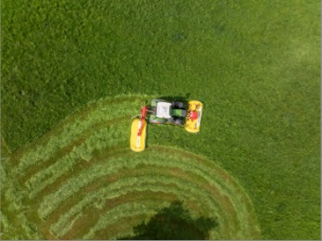 | 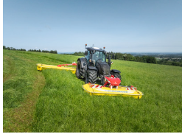
NOVACAT F 3100 OPTICURVE,  NOVACAT H 11200 | NOVACAT F 3100 OPTICURVE,  NOVACAT H 11200
https://www.poettinger.at/de_at/newsroom/pressebild/170879 | https://www.poettinger.at/de_at/newsroom/pressebild/170881

More printer-optimised photos: http://www.poettinger.at/presse

