NOVACAT V 9200 CF: New model for
merging swaths without a conditioner

The Austrian agricultural machinery manufacturer Pöttinger launched a revolution in mowing technology some years ago, making it possible to merge swaths without using conditioners. CROSS FLOW is the name of this cost effective system. A cross flow auger is integrated into the mower to deposit the forage either merged into a swath, or spread over the working width of the rear mower, or as a wide swath to one side. CROSS FLOW is now also available for the NOVACAT V 9200. This mower combination features impressively low weight and a low power requirement.

Feedback from the field was the basis for this development, following demand for a cost-effective and straightforward system for merging swaths. CROSS FLOW works without a conditioner and is characterised by its low weight compared to conventional swath merging systems. This technology ensures optimum conservation of the forage and soil, as well as the running costs, thanks to the fuel savings.

And, without a conditioner, the forage is handled extremely gently. Thanks to the closed trough shape, the forage is transported directly from the sward to the swath. This prevents forage losses, minimises dirt ingress and avoids disintegration losses.

The NOVACAT V 9200 CF with CROSS FLOW auger can be used very effectively on grassland as well as with whole plant silage.

Photo preview:
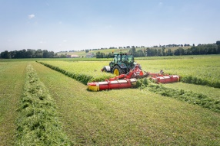 | 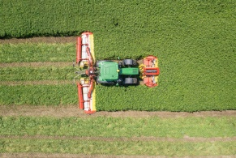
NOVACAT V 9200 CF for perfect swath placement | CROSS FLOW swath merging
https://www.poettinger.at/de_at/newsroom/pressebild/143650 | https://www.poettinger.at/de_at/newsroom/pressebild/143651

More printer-optimised photos: www.poettinger.at/presse

