Rebranding of production facility in San Vito, Italy

Pöttinger and MaterMacc celebrate new look and further expansion of production
Since the purchase of MaterMacc in 2022, the Austrian agricultural machinery manufacturer Pöttinger has bundled its expertise in precision seeding technology in San Vito al Tagliamento, Italy. The rebranding of the exterior and interior of the buildings not only brings a contemporary look, it’s a strong symbol for the good cooperation of the teams from Italy and Austria, and strengthens the location. The new appearance was celebrated on 16 December 2025 in a festive setting with around 65 guests.
The San Vito facility has been continuously improved over the past three years. Proven MaterMacc machines such as seed drills, hoeing machines or fertiliser hoppers, operating elements for electronic irrigation control, monitoring technology for seed drills and, of course, precision seeding, continue to be produced in San Vito, and will be available from MaterMacc partners as usual.
Pöttinger is now also producing the AMICO seed hopper, the LIQUIDO F silage additive hopper / front weight and the well-known Pöttinger crop care machines in Italy.
During the ceremonial address, Cristiano Giacomello (San Vito Plant Manager), Herbert Wagner (Managing Director Human Resources & IT) and TC Truesdell (Marketing Director) emphasised the symbolic power of the event: "This ceremony is an expression of the successful cooperation since 2022 and at the same time a signal for further expansion of production here at the Pöttinger facility in San Vito!"

Photo Preview:

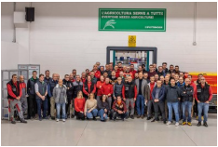 | 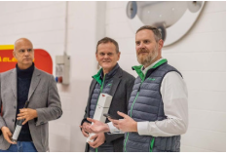
Everyone needs Agriculture! | Cristiano Giacomello (San Vito Plant Manager), Herbert Wagner (Managing Director Human Resources & IT) and TC Truesdell (Marketing Director)
https://www.poettinger.at/de_at/newsroom/pressebild/183184 | https://www.poettinger.at/de_at/newsroom/pressebild/183185

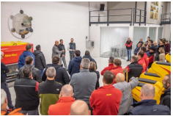 | 
https://www.poettinger.at/de_at/newsroom/pressebild/183186 | https://www.poettinger.at/de_at/newsroom/pressebild/183180

Weitere druckoptimierte Bilder: http://www.poettinger.at/presse

