Pöttinger presents new arable products
Arable farming specialist Pöttinger has once again tied up a colourful bouquet of innovations for the new season. There is something new from ploughs to seed drill to crop care machines.

SERVO 3000 – new hitch-mounted reversible plough
Arable specialist Pöttinger now introduces a new hitch-mounted reversible plough in the medium power class up to 200 hp: the SERVO 3000. For this new model, the engineering department has borrowed many of the features of the more powerful SERVO 4000 to unite durability, easy operation and perfect working results. The SERVO 3000 ploughs are available with three to five furrows, as well as various point-to-point spacings and underbeam clearances.

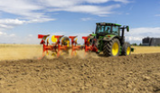 | 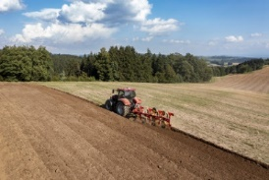
The SERVO 3000 hitch-mounted reversible plough for the best working results | With the SERVO 3000 PN, Pöttinger introduces a reliable and well-thought-out plough
https://www.poettinger.at/de_at/newsroom/pressebild/102884 | https://www.poettinger.at/de_at/newsroom/pressebild/110115

To the long version of the text:
https://www.poettinger.at/en_ie/newsroom/artikel/14539

TERRADISC with distribution system for AMICO F
For high output sowing during stubble cultivation or seedbed preparation, Pöttinger has now equipped not only its TERRIA stubble cultivators but also its trailed TERRADISC 8001 T / 10001 T disc harrows with a distribution system coupled to the AMICO F front hopper. Now, soil cultivation and sowing or fertilisation can be done at the same time.

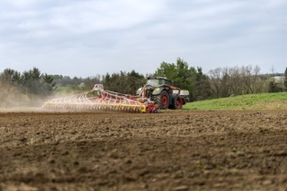 | 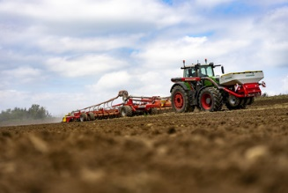
Tillage and application in a single pass: TERRADISC 1001 T, AMICO F | AMICO F front hopper and TERRADISC 10001 T with distribution system
https://www.poettinger.at/de_at/newsroom/pressebild/102084 | https://www.poettinger.at/de_at/newsroom/pressebild/102083

To the long version of the text:
https://www.poettinger.at/en_in/newsroom/artikel/14434

Rigid LION power harrows get a facelift
Best quality tilth and excellent mixing of the soil to form a perfect seedbed are highlights of Pöttinger power harrows. Combined with a seed drill, this machine becomes a flexible and high output combination delivering perfect drilling results. The tailor-made Pöttinger solution features LION power harrows with working widths from 2.5 m to 4.0 m and multiple equipment options to cover all types of soil and different farm sizes.
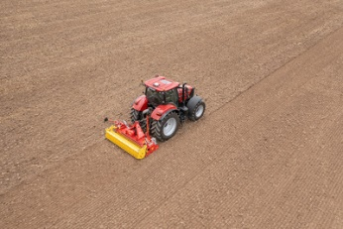 | 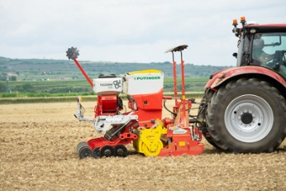
The LION 3030MASTER stands out with its new, eye-catching design | Varying operating conditions are the strengths of the LION 3030 MASTER with VITASEM M 3000 DD
https://www.poettinger.at/de_at/newsroom/pressebild/102541 | https://www.poettinger.at/de_at/newsroom/pressebild/102543

To the long version of the text:
https://www.poettinger.at/en_in/newsroom/artikel/14430

VITASEM mechanical seed drills with innovative features
Proven technology meets user-friendly, practical features, all in the latest generation of mechanical VITASEM seed drills. The machines are available as simple linkage-mounted seed drills and with the suffix M (mounted) as implement-mounted machines.

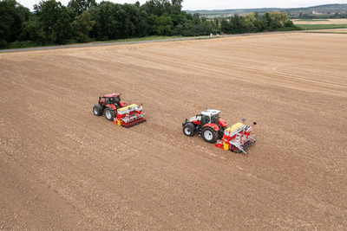 | 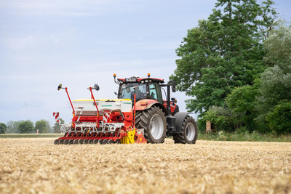
VITASEM M 3000 D mechanical seed drill for optimum seedbed preparation | Generous seed hopper increases output
https://www.poettinger.at/de_at/newsroom/pressebild/102542 | https://www.poettinger.at/de_at/newsroom/pressebild/102544

To the long version of the text:
https://www.poettinger.at/en_in/newsroom/artikel/14432

TERRASEM with the new Profiline comfort control system
TERRASEM seed drills combine efficiency with the highest level of flexibility and precision seed placement. In order to comply with feedback from the field in terms of making machines easier to use, the new Profiline comfort control system has been developed for universal seed drill technology.

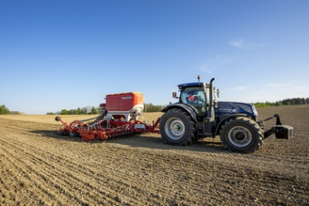 | 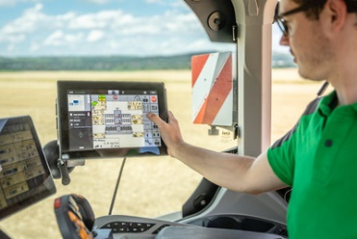
The TERRASEM V 6000 D Z with the new Profiline comfort control system for intelligent sowing | Intelligent, efficient sowing with the TERRASEM
https://www.poettinger.at/de_at/newsroom/pressebild/102523 | https://www.poettinger.at/de_at/newsroom/pressebild/102089

To the long version of the text:
https://www.poettinger.at/en_in/newsroom/artikel/14436

Enhanced features for ROTOCARE and FLEXCARE
The already proven ROTOCARE and FLEXCARE mechanical crop care machines from Pöttinger will get additional features in autumn 2023. These include the ability to mount a TEGOSEM hopper on the ROTOCARE V 6600 and V 8000 rotary hoes and optional automatic hoe element control using Section Control on all FLEXCARE row crop cultivators with working widths of 4.7 to 9.2 metres.
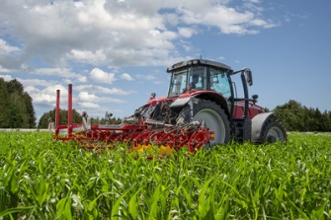 | 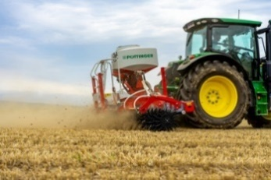
FLEXCARE V 6200 with precision control system | The TEGOSEM is mounted on the main frame
https://www.poettinger.at/de_at/newsroom/pressebild/105275 | https://www.poettinger.at/de_at/newsroom/pressebild/103003
To the long version of the text:
https://www.poettinger.at/en_in/newsroom/artikel/14530
Pöttinger TINECARE V MASTER: Every pass a success
Successful mechanical weed control depends on several factors. The crop, weeds, soil, weather, and the equipment parameters all play an important role. In order to be prepared for different operating conditions, there are a number of settings that can be made on the Pöttinger TINECARE V 12200 MASTER tine harrow with a working width of 12.20 metres. These machines will be available in the next few months.
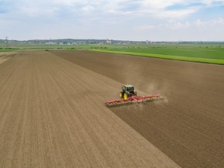 | 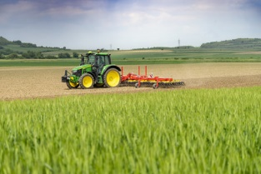
TINECARE V 12200 MASTER for high performance | With the TINECARE V 12200 MASTER every pass is a success
https://www.poettinger.at/de_at/newsroom/pressebild/103012 | https://www.poettinger.at/de_at/newsroom/pressebild/103080
To the long version of the text:
https://www.poettinger.at/en_in/newsroom/artikel/14531

More printer-optimised photos: http://www.poettinger.at/presse

