Pöttinger opens second phase
of plant in St. Georgen (AT)
Modern painting line goes into operation
On 14 April 2023, the second hall was officially opened at the new rake and baler plant in St. Georgen near Grieskirchen (AT). Following almost 1.5 years of construction, the agricultural machinery manufacturer Pöttinger has started up a modern cathodic dip priming (CDP) and powder coating line in this second expansion phase.

The highest quality - right from the start
With an investment of EUR 25 million, the first expansion phase of the St. Georgen plant was completed and production began in June 2021. The good order situation, combined with a large number of new products and the resulting need for increased capacity made the next step necessary: an additional hall for a sustainable priming and coating line. The additional building with an area of 7,900 m² including the new paint shop represents an investment volume of approximately EUR 33 million. The total production area has therefore been more than doubled.
The new priming and coating line now gives the parts for rakes and round balers their colourful coat of paint. These parts were previously delivered from the painting line at the headquarters in Grieskirchen. In addition, state-of-the-art methods attract contract orders from external firms requiring high-quality coatings. Industrial customers in particular, who have the same high corrosion protection specifications as Pöttinger, are impressed. Thanks to the advanced layout of the paint line, orders can be carried out in black CDP with high wall thicknesses and heavy unit weights. The maximum suspended load is 1,200 kg.

Top paint quality
The automotive quality paint finish using cathodic dip priming (CDP) and powder coating is an environmentally friendly process. No solvent is used in the mixing and application of the coatings. The painting process achieves excellent hardness and therefore a longer service life. Pöttinger brings together an environmentally friendly painting processes with sustainability.
"The finish of the paintwork also plays a major role in ensuring the high quality expected from our machines. The impact-resistant coating lasts the lifetime of the product. This was one of the reasons why we also invested in a painting line at this location," emphasises Gregor Dietachmayr, Speaker of the Executive Board, on this expansion phase.

Connected to nature and to people
As a family business, Pöttinger feels responsibility towards people and the environment. In addition to the sustainability aspects of building the new production hall (generous use of wood, green roof, PV system, reuse of residual heat, etc.), the design of the coating process also respects the highest possible conservation of resources and the environment.
The new building has also created further added value in the region. In addition to the approximately 60 employees assembling IMPRESS round balers, large TOP rakes and MERGENTO mergers, around another 50 people will find jobs here in a modern and ergonomically designed workplace.
The management team always keeps an eye on business developments and as a result is already planning the next expansion phases.

Photo preview:
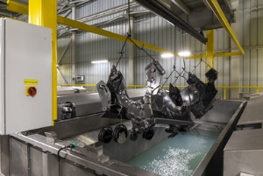 | 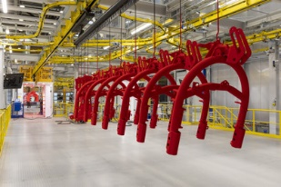
A view into the immersion pool | The highest level of paint quality even for large components
https://www.poettinger.at/de_at/newsroom/pressebild/93475 | https://www.poettinger.at/de_at/newsroom/pressebild/93473

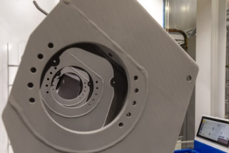 | 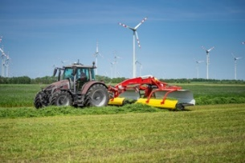
Modern and environmentally friendly painting process, right into the furthest corner | The best paint quality on the MERGENTO merger
https://www.poettinger.at/de_at/newsroom/pressebild/93504 | https://www.poettinger.at/de_at/newsroom/pressebild/65035

More printer-optimised photos: http://www.poettinger.at/presse

