PLANO VT 6060: New Stubble Cultivator from Pöttinger
Precision for shallow, all-over cutting

The agricultural machinery manufacturer Pöttinger expands its range of arable products with the new PLANO VT 6060 trailed stubble cultivator with a working width of 6 metres and 6 rows of tines. During development, great importance was attached to shallow and all-over cutting. This makes the cultivator the specialist for conserving groundwater, preventing erosion, mechanically suppressing weeds and tillage for catch crops. But it has even more to offer: With a working depth of up to 15 cm it is perfectly equipped for a wide range of tasks.

Engineered bodywork
The perfect interplay of bodywork, tines, shares and precise depth control across the whole working area are prerequisites for consistent, shallow tillage. The PLANO VT 6060 unites all these features while remaining compact. The 37 tines on the two frame sections are arranged symmetrically to prevent side pull and the disadvantages this entails. The result is tine spacing of 16.2 cm across a working width of 6 metres for good crumbling, mixing and levelling. The central ground clearance of 73 cm with underframe clearance of 60 cm allows cultivation even of high volumes of organic matter.

Holding the line or oscillating
At the heart of every PLANO are the tines fitted with shares. The arrangement and properties of these tines greatly influence the tilling process and the working results. That’s why two different tine systems are available for the PLANO VT 6060, depending on the prevailing soil conditions and characteristics of the area to be worked. The rigid tines with pressure springs are protected by these springs against overloading of up to 200 kg. The outstanding advantage of these tines is that they stay in line. This means that the tines and shares always remain in position, which ensures shallow all-over cutting and a constant working depth. Alternatively, the oscillating tines with coil springs made of 30x30-mm square spring steel can be selected. The strength of these tines lies in their oscillating mode of working and improved crumbling results, especially when preparing a seedbed and working in harvest residues.

Chisel points and duck foot shares
Both tine systems can be equipped with 200-mm-wide DURSTAR PLUS duck foot shares or 50-mm-wide DURASTAR chisel points. The shape of the duck foot shares makes them ideal for shallow, all-over movement and slicing. The reduced angle of penetration guarantees sufficient mixing results. In the interests of wear resistance, the degree of overlap has been optimised to improve resistance in the soil. The chisel points are particularly suitable for deeper tillage and intensive mixing, although they can also be used for shallow stubble cultivation.

Precise control
To ensure that the soil is cut as shallowly as possible but also over the widest possible area, precise depth control is crucial. The PLANO VT 6060 provides this control with its hydraulic depth adjustment effected by single or dual jockey wheels in the front and rear roller. To align the rear rollers with the jockey wheels without the need for any other alterations, adjustments of the hydraulic jockey wheels are transferred back to the rear rollers by means of an adjusting rod. This ensures that the rear roller is automatically and precisely adjusted in tandem with the jockey wheels so that the PLANO VT 6060 is always parallel to the ground. Thanks to the compact design, perfect ground tracking and maximum manoeuvrability are guaranteed.

Tailored to the job in hand
Additional options are available for the PLANO VT 6060 for safe working and great versatility. The knife roller known from the TERRADISC, for example, provides intensive shredding of organic material, ensures clogging-free work and helps initiate a uniform decomposition process. The front board supports the tines and shares with their work and ensures that the soil is crumbled and levelled for a perfectly prepared seedbed. Additionally, the adjustable trailed harroweeder can be attached at the rear. This implement deposits organic matter that has been separated from its roots on the surface and removes soil from the roots. This ensures fast drying. Several single and tandem rear rollers are available for perfect consolidation.

Cost-effective operation
The shares, available as DURASTAR and DURASTAR PLUS models, are tipped with tungsten carbide for high wear resistance and a long service life. This means that the share retains its shape for a long time, guaranteeing perfect working results. In order to use the power of the tractor as efficiently as possible and minimise any wheel slippage, the drawbar can be equipped with the TRACTION CONTROL hydraulic pulling power booster. This allows loads of up to 1,100 kg to be transferred to the tractor’s rear axle. Pressure can be adjusted for varying working depths. To combine work steps and reduce the number of passes, tillage can be combined with the application of catch crops by using the flexible TEGOSEM tank.

Versatility at work
The choice of tine systems, various shares and numerous equipment options make the PLANO VT 6060 a real all-rounder in arable farming all the year round. Its strengths lie not only in reliable separation of shoots and roots but equally in intensive mixing when preparing seedbeds and loosening to a medium depth of 15 cm. Impressive versatility and precision in every centimetre.

Photo preview:

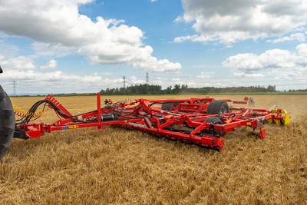 | 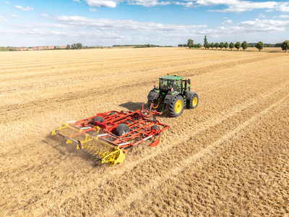
The PLANO VT 6060 trailed stubble cultivator has a working width of 6 metres and 6 rows of tines. | The optimised tines and shares guarantee shallow and all-over cutting from 3 m.
https://www.poettinger.at/de_at/newsroom/pressebild/152855 | https://www.poettinger.at/de_at/newsroom/pressebild/153468

More printer-optimised photos: http://www.poettinger.at/presse

