12 The agrirouter is coming
Simple and secure data exchange for farmers
Osnabrück/Hanover, September 2017. At the start of 2016 DKE-Data GmbH & Co. KG announced an Internet-based data exchange platform for farmers and contractors, which would be capable of connecting up machinery and agricultural software from a wide range of manufacturers. Now it is ready. DKE-Data presents the agrirouter at the Agricultural Technology Fair Agritechnica in November 2017 in Hanover, Germany.

The resolution of a fundamental problem
At its stand in Hall 15, DKE-Data GmbH & Co. KG presents a data-exchange platform that addresses a fundamental problem in the digitalisation of agriculture: The new tool allows farmers and contractors to exchange data between machinery and agricultural software applications from a wide range of manufacturers. Until now this possibility had eluded those farms with mixed fleets of agricultural machinery.
The new agrirouter simplifies data exchange and operational procedures, thus reducing administrative expenses and improving economic efficiency. This provides the farmer with more time to do other things. The whole system is controlled via the Internet. The user sets up his own personal agrirouter and sets rules to determine who can exchange how much data with whom. The agrirouter user always has a hand on what happens with his data.
The new tool enables farmers and contractors to optimise their agricultural production processes with regard to efficiency, use of operating resources, and energy and labour costs, from the very start until the delivery of the produced raw material or food. In addition, the option also exists to connect two agrirouters temporarily or permanently for the purposes of exchanging specific data and process optimisation.
Many transfers can be automated in the daily workflow. Handling is also facilitated by a one-time setting of basic parameters which can be altered at any time. The entire data transfer is secure and takes place via a rapid network. All activities comply with current data protection guidelines, or even surpass them considerably when it comes to security concerns. Never forget: The agrirouter transports data, but does not store it permanently.
The agrirouter can be used with any Internet capable device. Connection of your own machinery to the agrirouter occurs via communication units (telemetry boxes), which can also be provided to equip older fleet machinery. The communication units that are available as well as the agricultural software applications that can be used are listed in a publicly viewable marketplace.

Sign-up is free – low usage costs
The usage fees for the data transfer via the agrirouter are low, since DKE-Data GmbH & Co. KG operates as a non-profit company. The fees are charged to the user by his/her agricultural software provider. In addition, mobile phone fees are incurred for the transfer of data between machinery and the agrirouter.
In the future, agrirouter users will be able to register themselves free of charge before setting up their personal agrirouter on their PC, tablet or smartphone by connecting their machinery and their software. The official start of operations will be in spring 2018.
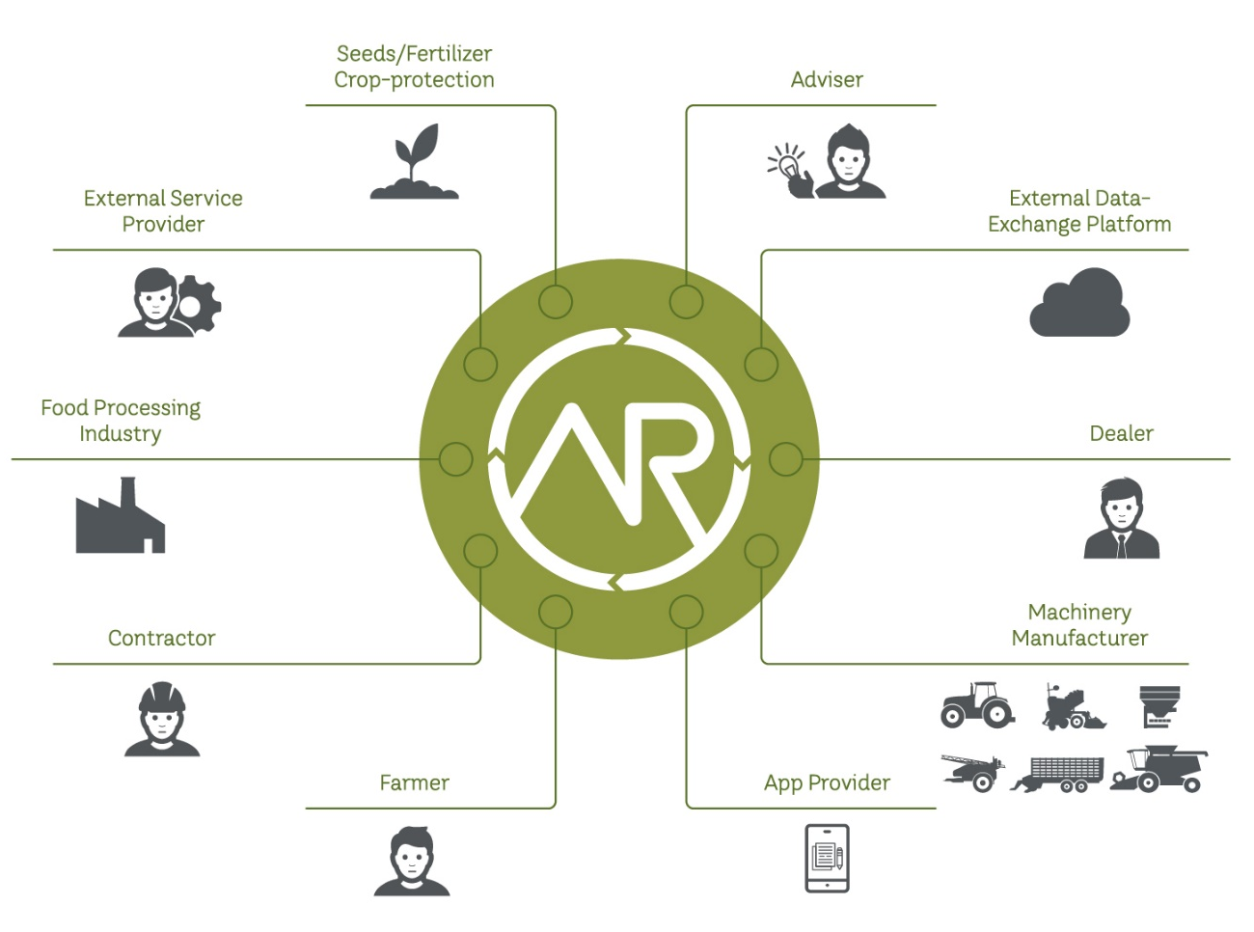
The open approach also allows other market players (e.g. producers of farming resources, agricultural trade, etc.) to make their digital products available in the marketplace.

Strong basis – strong developer
This project is supported by a consortium of renowned agricultural engineering companies who are also open for other members to join, and who have jointly recognised that farming 4.0 will only work if a manufacturer-independent and as such non-discriminatory exchange of data is made possible. Currently the consortium includes (in alphabetical order) AGCO, AMAZONE, DEUTZ-FAHR, GRIMME, HORSCH, KRONE, KUHN, LEMKEN, PÖTTINGER, RAUCH. Irrespective of their size, every member of the consortium has a single vote.
The software supplier for the agrirouter is SAP. This globally operating company can guarantee its reliable operation as well as an international usage of the agrirouter. The open approach also allows other market players (e.g. producers of farming resources, agricultural trade, etc.) to make their digital products available in the marketplace for the purposes of optimising agricultural production processes.
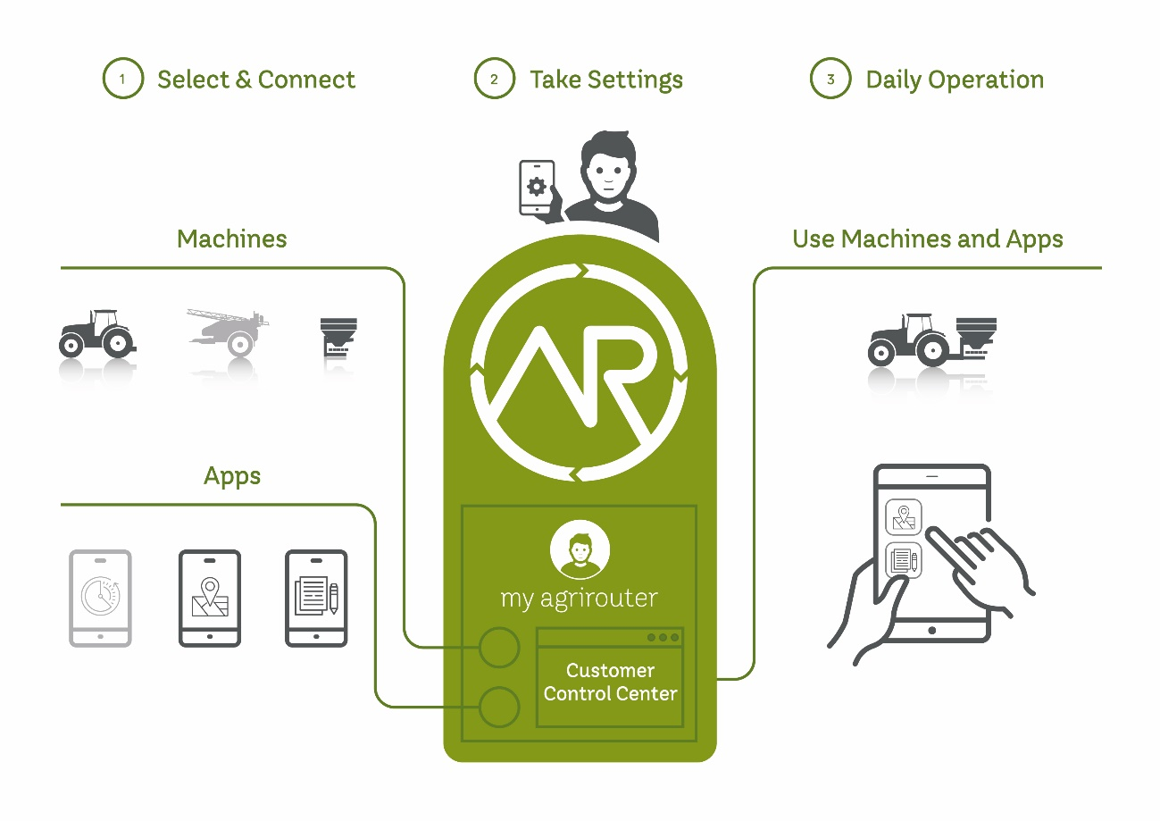
The user sets up his own personal agrirouter and sets rules to determine who can exchange how much data with whom. The agrirouter user always has a hand on what happens with his data.

Contact:
DKE-Data GmbH & Co. KG
Dr. Jens Möller / Dr. Johannes Sonnen
Albert-Einstein-Str. 1
49076 Osnabrück
Germany
Email: press@dke-data.com
www.dke-data.com
Tel.: Jens Möller +49 (0)541 2019 7001
Tel.: Johannes Sonnen +49 (0)541 2019 7002

About DKE-Data GmbH & Co. KG
The company became active in July 2016 as the successor to DKE GmbH, which was founded two years earlier, and has its headquarters in ICO, i.e. the Innovation Centre of Osnabrück. DKE-Data GmbH & Co. KG developed the idea of the manufacturer-neutral, multiproduct data exchange platform agrirouter in cooperation with the consortium partners and other donors, and instigated the necessary developments by tendering, allocating and control of the various work packages to external service providers. After the start of operations DKE-Data GmbH & Co. KG will also take on its role as the operating company for the agrirouter.

