JUMBO 7000 is FARM MACHINE 2022 Pöttinger receives award for new loader wagon
The high performance JUMBO 7000 series loader wagon by Pöttinger is two steps ahead thanks to its high efficiency and outstanding work quality. The new concept and its innovative features were what sealed the jury's decision for "FARM MACHINE 2022". The JUMBO won the trade journalists' vote in the forage harvesting category. The award was presented online on March the 4th, 2022.

The basis for success
"FARM MACHINE 2022", the international award for new products and innovations in agricultural technology was previously called "Machine of the Year". This coveted award in the agricultural machinery industry is presented by trade journalists working for international farming magazines. There is one winner in each of 12 categories (plus an audience choice award).
With this award, the jury recognised the uniqueness of the multi-purpose rotor loader wagon with its new drive concept, optimal power transmission and other, innovative core components. The JUMBO can look back on a successful past: 1999 was when its international success all started. 2009 the JUMBO was awarded a silver medal for AUTOCUT, the automatic knife sharpening system, at Agritechnica and was "Machine of the Year 2010". Pöttinger, the world market leader in loader wagons, has engineered the new JUMBO 7000 series for a maximum tractor output of 500 hp. The numerous new developments (movable front panel, intelligent automatic loading system, hydraulically controlled floating pick-up, additional tracking roller, new loading rotor and much more) make harvesting even more efficient. The new design has turned Pöttinger's flagship into an eye-catcher that makes work fun.
Pöttinger is delighted to have been awarded the title "FARM MACHINE 2022" in the forage harvesting category. Gregor Dietachmayr (Spokesperson for the Management Team) and Markus Baldinger (Managing Director Research, Development, Digitisation) accepted the award online: "This special award is pleasing confirmation that we have hit the mark with our high standards in the development of the new generation of the JUMBO. Top forage quality and cost effectiveness make the loader wagon process even more attractive." The two managing directors are pleased that Pöttinger is recognised internationally as a specialist for delivering the best working results.

Photo preview:

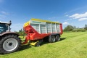 | 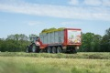
The JUMBO 7380 boasts a modern, eye-catching design of the new JUMBO | The high performance JUMBO 7450
https://www.poettinger.at/de_at/Newsroom/Pressebild/4807 | https://www.poettinger.at/de_at/Newsroom/Pressebild/4823

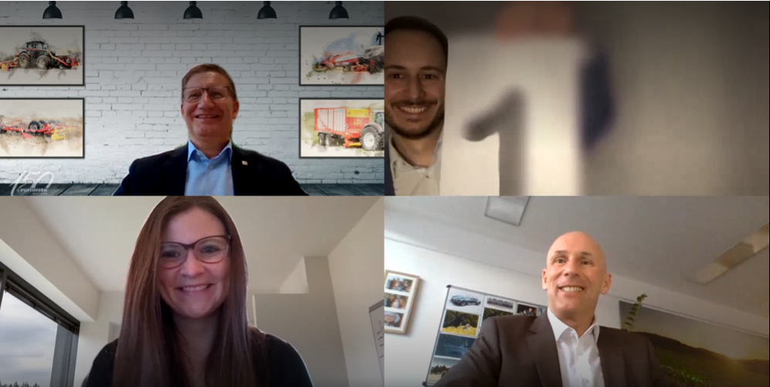

Top left: Markus Baldinger (Pöttinger) is proud of the latest generation in loader wagons' success
Top right: Claus Mayer, Editor-in-Chief of Traction presents the award
Below left: Evelyn Schmailzl, Traction, explains the jury's decision
Below right: Gregor Dietachmayr (Pöttinger) is delighted with the award

Video:
JUMBO - Two steps ahead
https://www.poettinger.at/de_at/Newsroom/Video/6bwIRYGGuXs

Logo “FARM MACHINE 2022”
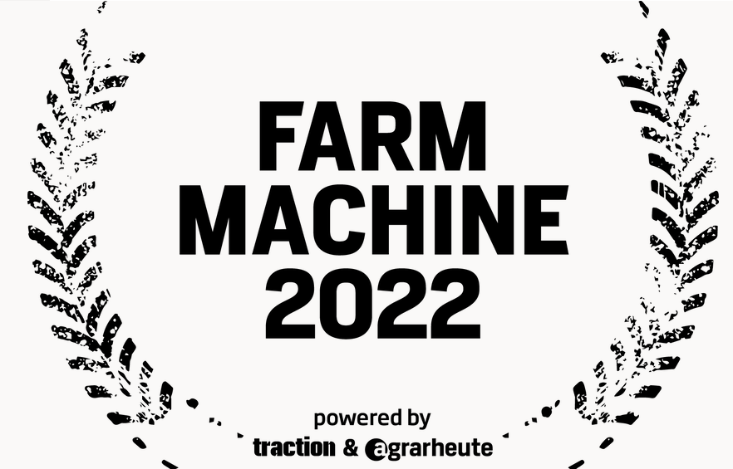

https://www.poettinger.at/de_at/Newsroom/Pressebild/5137

More printer-optimised photos: http://www.poettinger.at/presse

