HARVEST ASSIST:
Pöttinger and FarmDok optimise silage harvesting logistics
Pöttinger, the grassland specialist, always focuses on achieving the best working results and optimising processes when developing its machines and digital solutions. HARVEST ASSIST is a new, innovative app that Pöttinger has developed together with FARMDOK. The app helps to simplify and optimise the logistics of silage harvesting. The app will be available in German starting spring 2022, with other language versions being released from the 2023 season.

The innovation
HARVEST ASSIST optimises silage harvesting by taking into account harvesting volumes, the distance between the field and the clamp, and compaction performance in the clamp. In addition, the app enables real-time communication using existing hardware. Available for iOS and Android, every member of the harvest convoy can install the basic version of the app on their smartphone for free. This provides an intuitive overview for straightforward control of grass silage harvesting.

How does it work?
During the development of the app, the focus was on easy operation and reducing the volume of data to display only the most important information, as well as using inexpensive consumer electronics (i.e. mobile phones). In just a few steps, the fields can be added and assigned to each of the machines. The fields to be harvested and their current status are displayed very clearly. For example, the loader wagon driver can immediately see which fields have already been raked. Harvested areas are displayed to indicate the volume of crop remaining.

The algorithm that calculates the optimum harvest sequence is especially innovative. The harvest volumes, the distance between each field and the clamp and the compaction performance in the clamp are superimposed on the display. This provides the loader wagon drivers with information on the optimised harvesting sequence so that they deliver crop to the clamp at regular intervals and avoid delivery peaks. Thanks to the intuitive display of the individual fields in the app, it is also easy for drivers who are not familiar with the farm to find each field and drive back to the clamp quickly using the integrated navigation system.

The advantages at a glance
- The app uses existing smartphones instead of expensive hardware.
- It is easy to operate and very intuitive.
- The area to be raked and then harvested with the loader wagon is displayed very clearly.
- The harvest can be optimised dynamically based on the mass flow of the crop.
- The volume compacted per hour in the clamp is optimised based on the continuous supply of fresh material.
- The location information of group members can be shared in real-time.

Photo preview:

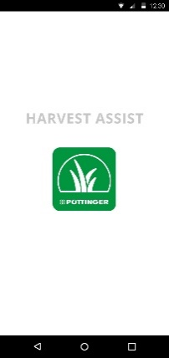 | 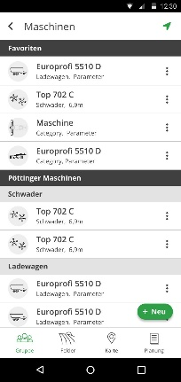
The start screen | The machines in the harvest convoy
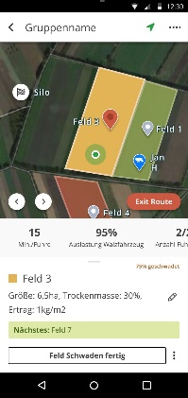 | 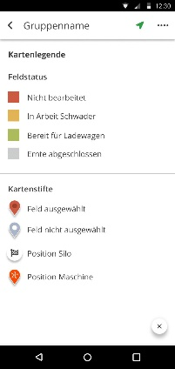
Description of the field (size, dry matter, yield) | Description of the map

More printer-friendly photos are available at: https://www.poettinger.at/presse

