The highest accolade:
Pöttinger leads in idea management
Idea management has been a part of the company organisation at Pöttinger - the agricultural machinery manufacturer - for many years. The pioneering Austrian company now stands out in Germany, winning 1st place at the German Idea Management Awards.

Continuous improvement counts
From Airbus to Viessmann, many well-known companies apply every year for the German Idea Management Award, the highest award for inhouse continuous improvement processes in Germany. This year was the first time that Pöttinger was assessed by the independent jury. The Austrian manufacturer's continuous improvement process has been highly successful: Pöttinger is the first Austrian company to win first prize in the top category "Best Idea Management 2020". The farm equipment manufacturer promotes the implementation of employees' ideas using their Kaizen together with “Pöttinger Improvement Process”. The international jury was impressed with the extent to which the continuous improvement process has been integrated. This is a key success factor not only at the Group's headquarters, but also across their international locations. The Kaizen Team is employed full time to conduct audits and improvement workshops on an ongoing basis at all locations. Both Production and Administration are scrutinised in detail. And that includes the Pöttinger seed drill technology plant in Bernburg, Germany, of course.
Due to the current situation, the prize was awarded digitally. People in the company are delighted, however: "Agricultural engineering is an innovative industry that lives from creative ideas. It is not just about the major innovations. The high volume of small, well-thought-out suggestions is what matters", is what Gregor Dietachmayr, Spokesperson for the Management Team, says about the success of the continuous improvement process. These save the company approximately EUR 6 million every year. Almost three out of four employees participate in the improvement process. The fact that it is also worth the effort for the employees is an essential factor. Depending on their outcome, the 7,000 ideas submitted every year are rewarded with bonuses that are sometimes considerable.

Photo preview:
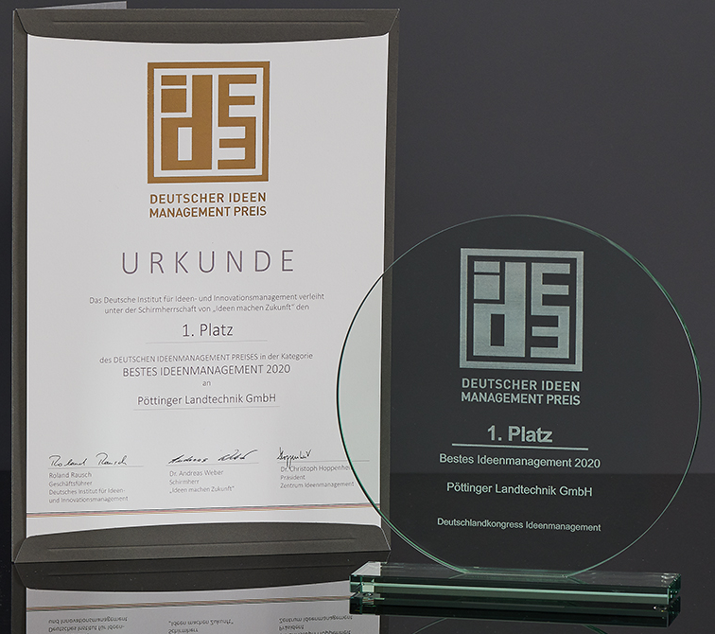 | 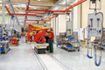
The coveted trophy for 1st place | Pöttinger implements creative ideas
https://www.poettinger.at/de_de/Newsroom/Pressebild/4513 | https://www.poettinger.at/de_at/Newsroom/Pressebild/4058

More printer-optimised photos: http://www.poettinger.at/presse

