New from Pöttinger: The PROFI 5000 loader wagon

A powerful and smooth-running entry to the rotor class
The PROFI sees Pöttinger enter a new era of rotor loader wagons. The PROFI 5000 is the smoothest-running model in this class of wagon offered by the agricultural machine professionals in Grieskirchen, Austria. With its high load capacity, it provides the optimum basis for harvesting high-quality forage.
The PROFI's controlled floating pick-up conserves the sward, reduces dirt ingress, and prevents wear on the tines. With an effective width of 2.1 m, the pick-up collects the crop cleanly and tidily even in difficult conditions, transfers it to the powerful double-tine rotor which passes it through the 31-knife short-chop chopping system (theoretical chopped length 45 mm). At just 4 mm thick, the knives enable smooth running, efficient harvesting with around ten percent less power required for chopping compared to knives that are 5 mm thick. For convenient access, the machine is equipped as standard with the EASY MOVE swing-out knife bank with central knife release system. Optimum filling of the wagon is ensured by the large, movable forage compression flap in the fixed panel at the front of the loading chamber.
The automatic loading system, which is installed as standard on the PROFI 5000, distributes the loading power evenly so that the loader wagon fills right up, is easy to operate, and handles high transport capacities. A sensor on the front panel measures the pressure created by the incoming forage. An angle sensor on the forage compression flap measures the movement of the flap.
Unloading is just as convenient with a stepless motor working together with the automatic unloading system. This controls the tailgate, scraper floor, and, on DB models, also the beater rotors.
To conserve the soil, which is a valuable resource, the PROFI 5000 is fitted with large 710/35R22.5 tyres (on the 13-tonne chassis).
For collecting and transporting dry crops such as hay, straw and alfalfa, which have a low specific density, Pöttinger has especially developed the high-volume PROFI DF Dry Forage models with optional roof profiles.
The PROFI 5000 from Pöttinger is the ideal entry into the rotor class of loader wagons and is an all-rounder that can handle any crop.

Photo preview:
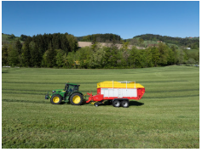 | 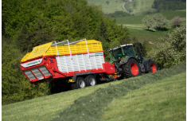
The PROFI 5000 is powerful and smooth-running | Clean forage and a high load capacity
https://www.poettinger.at/de_at/newsroom/pressebild/191824 | https://www.poettinger.at/de_at/newsroom/pressebild/191830
More printer-optimised photos: http://www.poettinger.at/presse

