NOVACAT ALPHA MOTION PRO is
„Machine of the Year 2020“
Second award for Pöttinger his year
With the new NOVACAT ALPHA MOTION PRO models, the enjoyment of mowing takes on a new dimension: The revolutionary front mower technology was awarded as “Machine of the Year” at the Agritechnica in Hanover (DE). An international jury from eleven nations awarded the coveted prize in a total of 15 categories. Pöttinger received the prestigious award in the "Haying" category.
The jury praised the easy attachment to any tractor and the proven kinematics of the active support frame.
With the ALPHA MOTION headstock the entire carrier frame adapts to the ground contours. Each movement controls the carrier frame to ensure a "floating cut". Even at high speeds and over wet ground, which results in a unique conservation of the swaths. The mower is guided harmoniously over each bump in the ground, which means that it is less stressed and wear is reduced.

The award ceremony took place on 12th November 2019. Gregor Dietachmayr (Speaker of the Executive Board), T.C. Truesdell (Marketing Director) and Daniel Ratzberger (Director Product Management) accepted the award.

Following the "Machine of the Year 2019" award for the NOVACAT CROSS FLOW at SIMA in Paris (FR), this new award is a welcome sign that Pöttinger is also internationally known as the "Specialist for the best work results".

Preview:

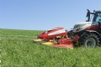
The eye-catching new NOVACAT ALPHA MOTION PRO | Enjoy a new dimension in mowing
https://www.poettinger.at/de_at/Newsroom/Pressebild/4205 | https://www.poettinger.at/de_at/Newsroom/Pressebild/4204

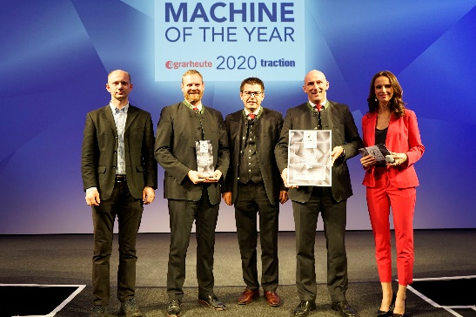

https://www.poettinger.at/de_at/Newsroom/Pressebild/4409

The award
F.l.: Frederik Masur (Agrartechnik), T.C. Truesdell, Daniel Ratzberger, Gregor Dietachmayr (PÖTTINGER Landtechnik) with the presenter oft he evening

Logo “Machine of the year”:

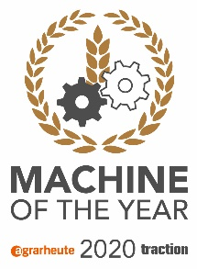
https://cdn.poettinger.at/img/landtechnik/collection/sonstiges/poettinger_logo_maschine_des_jahres_hq.jpg

More printer-optimised photos: http://www.poettinger.at/presse

