Pöttinger: No SIMA participation in Paris in 2024

The family-owned company Pöttinger is well positioned internationally and uses its activities and resources in a targeted manner to achieve the greatest possible efficiency and customer proximity. Trade fairs and exhibitions play a major role to accomplish this goal. However, international trade fairs taking place at nearly the same time creates certain challenges for both exhibitors and visitors. In close consultation with the company headquarters and responsible persons in France, it was decided to cancel participation at the SIMA 2024 in Paris.
Closer to the clients
SIMA, the largest French trade fair for agriculture, will take place in November 2024 - without Pöttinger. In the pandemic years, the trade fair landscape and visitor behaviour changed considerably. "We will focus our resources more specifically into communicating directly with our clients. We will emphasize activities that address our end customers and their needs. We want to support them in the best possible way, according to the motto: "Everyone needs agriculture!", Gregor Dietachmayr, Speaker of the Executive Board, comments on the decision. The direct contact enables the company to convey its innovative product portfolio and digital solutions for grassland and arable farming products even better. Activities will continue to include local and national events alike. However, focus will be placed on flexible product training and presentations tailored to customer needs.
As a company with a long tradition, Pöttinger is of course sticking to the trade fair tradition and will continue to participate in international trade fairs. "As a globally active company, we would like the international trade fair organisations to coordinate their schedules better for the benefit of the exhibiting companies and visitors," explains Dietachmayr. With the relief of the bulging trade fair calendar, the attractiveness of individual events can certainly be increased again.

Preview:
 | 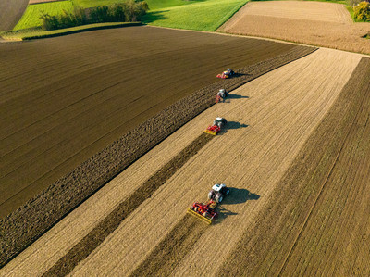
Gregor Dietachmayr,  Speaker of the Executive Board | The wide range of products for arable farming
https://www.poettinger.at/de_at/Newsroom/Pressebild/5232 | https://www.poettinger.at/de_at/newsroom/pressebild/89093

