Pöttinger: Update for crop care machines
Enhanced features for ROTOCARE and FLEXCARE
The already proven ROTOCARE and FLEXCARE mechanical crop care machines from Pöttinger will get additional features in autumn 2023. These include the ability to mount a TEGOSEM hopper on the ROTOCARE V 6600 and V 8000 rotary hoes and optional automatic hoe element control using Section Control on all FLEXCARE row crop cultivators with working widths of 4.7 to 9.2 metres.

ROTOCARE - even more flexible in action
In addition to weed management, the ROTOCARE can also be deployed for numerous other applications. The rotary hoe is also suitable for breaking up encrusted soil, incorporating fertiliser, applying seed materials or trace element nutrients, and shallow stubble cultivation. The wide range of applications increases the flexibility of the machine as well as its utilisation. The ROTOCARE's effective driving speed range is between 10 and 30 kph. The driving speed needs to be adapted to the operating conditions.

TEGOSEM hopper
The flexible TEGOSEM hopper combines soil cultivation and sowing a cover crop, microgranules or a companion crop in a single pass to save time and costs. To optimise the centre of gravity, the TEGOSEM is mounted on the main frame of ROTOCARE rotary hoes with working widths of 6.6 and 8 metres. A loading platform ensures safe filling of the 200 and 500 litre hopper.

FLEXCARE - maximum flexibility
The unique concept of the FLEXCARE row crop cultivator made by Pöttinger offers full flexibility working in a variety of crops. To match the row spacing of the crop, the working width of the hoe elements, the correct position of the coulter and the fine settings of the finger hoe can be adjusted completely without the need for tools. The machine features precise depth control in all operating conditions and crop-conserving operation.

Precision operation with Section Control
The optional Section Control system raises and lowers the hoe elements with pinpoint accuracy using GPS. This happens automatically when the headland boundary is reached. Ultimately, it protects the crop in field corners, overlaps and along field edges. Each hoe element has a double-acting hydraulic cylinder to raise and lower the hoe according to GPS signals at the headland and in field corners. This means less fatigue for the driver, who can focus on the working results of the row crop cultivator.

Photo preview:
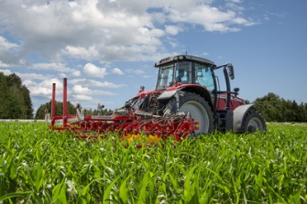 | 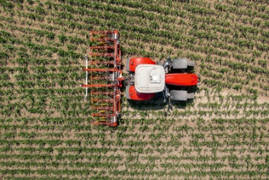
FLEXCARE V 6200 with precision control system | FLEXCARE V 6200 does a great job in wedge-shaped fields
https://www.poettinger.at/de_at/newsroom/pressebild/105275 | https://www.poettinger.at/de_at/newsroom/pressebild/105274

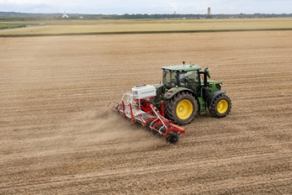 | 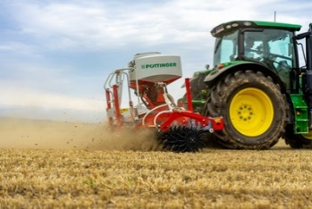
The ROTOCARE V 6600 rotary hoe with flexible TEGOSEM hopper | The TEGOSEM is mounted on the main frame
https://www.poettinger.at/de_at/newsroom/pressebild/103002 | https://www.poettinger.at/de_at/newsroom/pressebild/103003

More printer-optimised photos: http://www.poettinger.at/presse

