PLEASE DO NOT PUBLISH BEFORE 27 August 2026 at the earliest

New SYNKRO cultivators from Pöttinger

Universal cultivators packed with impressive new features
A multitude of new and proven features as well as numerous customisation options make the new SYNKRO stubble cultivator a true all-rounder in conservation tillage. The linkage-mounted, 2-gang (rigid, with a working width of 2.5 m or 3 m) and 3-gang (rigid or folding, 3 m to 5 m) SYNKRO universal cultivators are excellent at stubble cultivation, primary tillage in autumn, seedbed preparation for mulch drilling, and terminating cover crops.
The rigid variants are now also available with depth wheels as an option. These ensure a consistent working depth, particularly on rough ground and undulating fields, which is perfect for preparing the soil ahead of the seed drill.
This means that the rear roller can be easily removed from both the rigid and folding versions when required. Working without rear rollers results in a loose, non-consolidated soil structure, so it is ideal for primary tillage in autumn and for farms that operate without deploying a plough. When used without rear rollers, organic matter remains on the surface, significantly reducing the risk of soil erosion.
The SYNKRO V models with hydraulic folding have four parking stands available as an option. This allows the machines to be stowed safely in the folded position to save space. In addition, the symmetrical tine configuration on these models ensures that they operate without side pull and produce excellent levelling results.

Convenience and reliability
The NOVA mechanical stone protection system with horizontal springs and a triggering pressure of 550 kg is now maintenance-free. The levelling tools on the SYNKRO V can be conveniently adjusted from a central point and are now equipped with overload protection on all models. Adaptable settings, a selection of tillage tools, and a choice of equipment options, allow a site-specific strategy to handle a wide variety of operating conditions. A precise machine set-up enables uniform working results that provide the basis for subsequent work steps and success in arable farming.
The new SYNKRO cultivators from Pöttinger tick all the boxes for convenience, reliability and versatile applications. With their impressive choice of configurations, they are ideal for small family-run farms as well as large farming operations and machinery rings.

Photo preview:
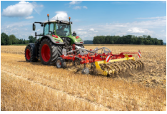 | 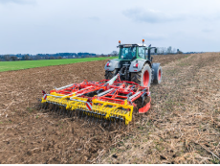
The new SYNKRO is packed with updates and new features | A true all-rounder in conservation tillage
https://www.poettinger.at/de_at/newsroom/pressebild/191269 | https://www.poettinger.at/de_at/newsroom/pressebild/191268
More printer-optimised photos: http://www.poettinger.at/presse

PLEASE DO NOT PUBLISH BEFORE 27 August 2026 at the earliest

