Pöttinger will establish sales subsidiary in the Netherlands
Agricultural machinery manufacturer takes another step towards successful internationalisation
With the founding of PÖTTINGER Netherlands, the world market leader in loader wagons will intensify its presence in the important Dutch market. The new subsidiary will bring the specialist for arable farming and grassland even closer to its customers and to the pulse of the times. Pöttinger will be able to supply the Dutch agricultural machinery trade even better with machines, service and spare parts. The founding process should be completed by autumn 2024. With a stable export share of around 90 percent, the Austrian family business is a leading global player in the agricultural machinery market.
More success with Pöttinger
The long-established company Duport, based in Dedemsvaart, has been the Dutch importer for Pöttinger and has achieved a high market share. The partnership began with selling Pöttinger loader wagons. Thereafter, from 2007 to 2024, the importer offered the entire Pöttinger portfolio. After more than 20 years of successful collaboration with Duport, Pöttinger will serve the Dutch agricultural machinery trade directly. This is a clear advantage for the farmers: more direct communication and support for complex machines as well as more knowledge will increase overall efficiency.
This strategic decision was preceded by intensive discussions due to changes in the general business conditions. The negotiations have led to the mutually agreed result that the cooperation with Duport will be terminated in its current form.
"We are prepared to meet the challenges that have arisen in recent years. The time has come, and circumstances make it a necessity, for us to reorganise our activities and further improve our overall performance. For us as an Austrian family business, our focus is on the people. We will do everything possible to ensure a smooth handover - for existing customers, our partners, and our experienced team members," states Gregor Dietachmayr, Speaker of the Executive Board, delighted with the latest addition to the Pöttinger family.

Bildvorschau:
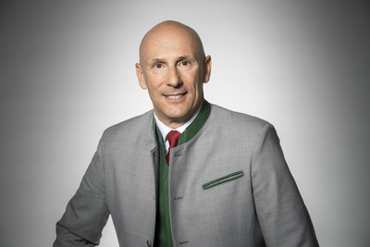 | 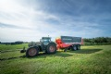 | 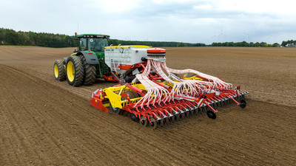
Gregor Dietachmayr, Speaker of the Executive Board | The JUMBO 8450 with short-chop chopping system | AEROSEM VT 6000 DD, with Profiline comfort control system
https://www.poettinger.at/de_at/newsroom/pressebild/73748 | https://mediapool.poettinger.at/pinaccess/showpin.do?pinCode=Q4Q6L0x6f3R9 | https://www.poettinger.at/de_at/newsroom/pressebild/143619

Weitere druckoptimierte Bilder: www.poettinger.at/presse

