Pöttinger launches the TOP VT 12540 C
Top performance for the best forage

As a specialist in grassland farming, Pöttinger always focuses on the highest quality and the most efficient way to get the best forage. The agricultural machinery manufacturer is now extending its range of four-rotor rakes with the new TOP VT 12540 C, which features an impressively compact design and great manoeuvrability. Thanks to its low weight, this rake can also be used safely on steep ground without compromising on performance.

Perfect raking work for clean forage
The angled tines on the TOP VT 12540 C lift the crop slightly to ensure it is swept cleanly without dragging the forage across the ground. The rotor chassis can be supplied with four or five wheels, depending on requirements. Together with the MULTITAST jockey wheel system, perfect adaptation to every bump in the ground is guaranteed. The raking height is adjusted manually using a hand crank. This also automatically adjusts the MULTITAST jockey wheel together with the rotor chassis.
Because the rotor is mounted in gimbals, the rake offers plenty of freedom of movement to ensure three-dimensional ground tracking. The front rotor units feature hydraulic weight alleviation and the rear units have mechanical suspension. This ensures uniform distribution of ground pressure.

Application flexibility and adaptability
The working width of the TOP VT 12540 C can be adjusted hydraulically whenever needed. Working in wedge-shaped fields and around obstacles such as electricity pylons or trees is no problem. All four rotors are driven mechanically by cardan shafts. Depending on which machine will be used to collect the harvest, the rear rotors can be shifted into in three positions without the need for tools. The width of the swath can be set between 1.20 and 2.00 m.

Convenient operation and straightforward handling
The rake is attached using a strong yoke. Double sided linkage lugs ensure an extended service life and allow a tight turning angle. The TOP VT 12540 C is supplied with the Basicline preselect system as standard. One double-acting spool valve controls the lifting and folding of all the rotors. Integrated stepping valves ensure that the front rotors are always lifted and lowered first. Using the BASIC CONTROL terminal, the front two rotors can be lifted and lowered together or separately. To adjust the working width, the two front rotors are operated together using a separate spool valve.

During road transport, the rake is under 4.00 m without removing the tine arms, which makes handling much easier.

Short windows for harvesting demand high output farm machinery, which is exactly what the Pöttinger TOP VT 12540 C delivers, along with very compact dimensions.

Photo preview:
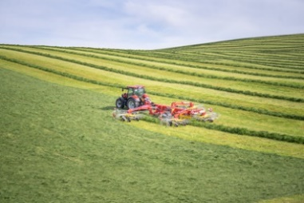 | 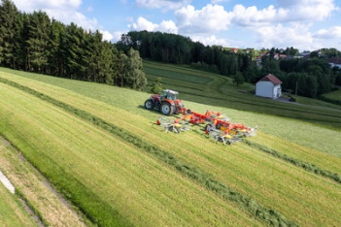
The TOP VT 12540 C stands for maximum output and manoeuvrability | Neat raking is guaranteed with the new TOP VT 12540 C
https://www.poettinger.at/de_at/newsroom/pressebild/135616 | https://www.poettinger.at/de_at/newsroom/pressebild/135615

More printer-optimised photos: www.poettinger.at/presse

