Pöttinger TOP VT 12540 C four-rotor rake - now with Profiline comfort control system
The TOP VT 12540 C is a compact four-rotor rake that can be used safely on inclines without compromising on performance. This manoeuvrable rake is now also available with the Profiline comfort control system as an option, bringing with it a range of useful functions and operating modes.
Maximum convenience
Direct mode makes it easy to lift any rotor unit individually by simply touching the display screen. Being able to operate individual rotors quickly and conveniently is very helpful, especially when there are obstacles within the field.
Wedge-shaped swath mode makes it easier to rake wedge-shaped fields. When a front rotor is lifted or lowered, the respective rear rotor follows as soon as it reaches the same point. The left and right front rotors can be controlled independently of each other.
The raking height can be adjusted electro-hydraulically from the tractor cab as an option. This works for all four rotors at the same time, or individually. Depending on the equipment options fitted, the MULTITAST jockey wheel system is adjusted automatically with the rotor chassis.
Section control is standard
TOP VT rakes with the Profiline comfort control system are section control capable as standard. Using this system and the corresponding equipment on the tractor, the individual rotor units can be automatically lifted and lowered at the headland, depending on the GPS position.
Overlap control and automatic weight alleviation
When cornering, the overlap control moves the front rotor on the inside of the corner inwards automatically. Sufficient overlap with the rear rotor is then ensured at all times. When driving straight ahead again, the front rotor then moves out automatically.
The automatic weight alleviation system optimises the pressure the front rotor units apply to the ground. The amount of weight alleviation is adjusted automatically depending on the working width.
Ready for transport at the touch of a button
Simply press a button to change from working mode to transport mode, so the machine automatically retracts the working width, folds in the rotors, and locks them securely in place.
Successful model gets decisive upgrade
The TOP VT 12540 C four-rotor rake celebrated its debut in 2024. With its four or five-wheel chassis and the MULTITAST jockey wheel, it rides perfectly over every bump in the ground. The front rotor units feature hydraulic weight alleviation and the rear units have mechanical suspension. The working width of the TOP VT 12540 C can be adjusted hydraulically between 10 and 12.50 m.
TOP VT rakes are supplied with the Basicline preselect system as standard, which is operated using two double-acting spool valves and the BASIC CONTROL terminal. The optional Profiline comfort control system requires a tractor with load sensing or power beyond hydraulics. With the Profiline system, the rake is conveniently operated using either an ISOBUS tractor terminal or another control terminal such as the CCI 1200, EXPERT 75, or POWER CONTROL.
Regardless of which equipment options are chosen, the Pöttinger TOP VT 12540 C four-rotor rake stands for maximum output and manoeuvrability.

Photo preview:
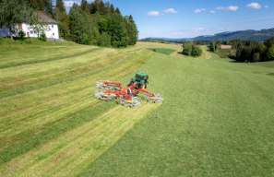 | 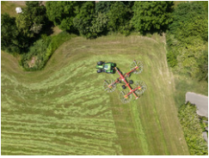
The TOP VT 12540 C stands for the highest output and stability on inclines | Overlap control: When cornering, the front rotor on the inside of the corner moves inwards automatically.
https://www.poettinger.at/img/mediapool/assets/170438/2000/TOP_VT_12540_C_JohnDeere_66.jpg | https://www.poettinger.at/img/mediapool/assets/170574/2000/TOP_VT_12540_C_DeutzFahr_33-1.jpg

More printer-optimised photos: www.poettinger.at/presse

