TOP V 6520 C: The new manoeuvrable rake from Pöttinger

Featuring an innovative pivoting headstock and optimum ground tracking for high forage quality
The new TOP V 6520 C is a compact twin rotor rake without chassis that delivers impressive manoeuvrability and is ideal for farms with consistently high volumes of forage and complex logistics. Featuring an innovative pivoting headstock, the rake follows the tractor perfectly when cornering and rakes a central swath. The high centring force of the mechanical stabiliser struts on the pivoting headstock allows the machine to run smoothly without swaying from side to side. In addition, the machine is prevented from running forward when driving downhill.
The floating rotor suspension ensures three-dimensional ground tracking. The new MULTITAST jockey wheel is available as an option and is mounted directly on the headstock, allowing the rake to glide over any bumps in the ground. Equipped with these features, the rake works neatly to ensure a low crude ash content and high forage quality. The tandem axles compensate perfectly for uneven ground. This results in very smooth running, even at high speeds.

Smooth manoeuvring and compact on the road
At the headland, the machine is lifted by the tractor linkage and gently moved into the centre position. The high ground clearance of the TOP V 6520 C makes headland turns easier and prevents disruption of the already-formed swaths. The TOP V 6520 C is also compact during transport with its centre of gravity close to the tractor.

Reliable and flexible machine
The working width can be adjusted mechanically from 5.9 m to 6.5 m and can be adapted to the geometry of each tractor. This produces swath widths between 1 and 1.6 m. The TOP V 6520 C rake is therefore ideal for handling heavy forage in combination with smaller harvesting machines.
This new rake sees Pöttinger deliver a rock-solid design. Weight and costs have been saved at the same time as achieving maximum robustness. The TOP V 6520 C is a flexible machine that you can rely on, especially during short windows of optimum harvesting time.

Photo preview:
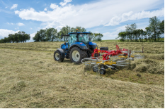 | 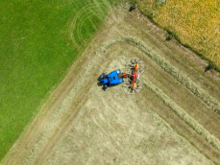
The TOP V 6520 C is compact and manoeuvrable | The twin rotor rake with central swath placement ticks all the boxes with the best ground tracking
https://www.poettinger.at/de_at/newsroom/pressebild/192130 | https://www.poettinger.at/de_at/newsroom/pressebild/191893
More printer-optimised photos: http://www.poettinger.at/presse

